


Maintain the safety of premises and personnel
D1.HSS.CL4.04
Trainee Manual






Maintain the safety of premises and personnel

D1.HSS.CL4.04

Trainee Manual





Project Base
William Angliss Institute of TAFE
555 La Trobe Street
Melbourne 3000 Victoria
Telephone: | (03) 9606 2111
Facsimile: | (03) 9670 1330
Acknowledgements
Project Director: | Wayne Crosbie
Chief Writer: | Alan Hickman
Subject Writer: | Alan Hickman
Project Manager/Editor: | Alan Maguire
DTP/Production: | Daniel Chee, Mai Vu, Riny Yasin, Kaly Quach

The Association of Southeast Asian Nations (ASEAN) was established on 8 August 1967. The Member States of the Association are Brunei Darussalam, Cambodia, Indonesia, Lao PDR, Malaysia, Myanmar, Philippines, Singapore, Thailand and Viet Nam.
The ASEAN Secretariat is based in Jakarta, Indonesia.
General Information on ASEAN appears online at the ASEAN Website: www.asean.org.
All text is produced by William Angliss Institute of TAFE for the ASEAN Project on “Toolbox Development for Front Office, Food and Beverage Services and Food Production Divisions”.
This publication is supported by the Australian Government’s aid program through the ASEAN-Australia Development Cooperation Program Phase II (AADCP II).
Copyright: Association of Southeast Asian Nations (ASEAN) 2013.
All rights reserved.
Disclaimer
Every effort has been made to ensure that this publication is free from errors or omissions. However, you should conduct your own enquiries and seek professional advice before relying on any fact, statement or matter contained in this book. The ASEAN Secretariat and William Angliss Institute of TAFE are not responsible for any injury, loss or damage as a result of material included or omitted from this course. Information in this module is current at the time of publication. Time of publication is indicated in the date stamp at the bottom of each page.
Some images appearing in this resource have been purchased from stock photography suppliers Shutterstock and iStockphoto and other third party copyright owners and as such are non-transferable and non-exclusive. Clip arts, font images and illustrations used are from the Microsoft Office Clip Art and Media Library. Some images have been provided by and are the property of William Angliss Institute.
Additional images have been sourced from Flickr and SXC and are used under Creative Commons licence: http://creativecommons.org/licenses/by/2.0/deed.en
File name: TM_Maintain_the_safety_of_premises_&_personnel_refined.docx





Table of contents
Introduction to trainee manual 1
Unit descriptor 3
Assessment matrix 5
Glossary 7
Element 1: Respond to fire and other alarms 9
Element 2: Respond to safety threats 23
Element 3: Respond to emergency situations 35
Element 4: Conduct evacuations 49
Element 5: Fulfil administrative responsibilities 73
Element 6: Respond to a deceased person situation 81
Presentation of written work 93
Recommended reading 95
Trainee evaluation sheet 97
Trainee self-assessment checklist 99

Introduction to trainee manual

To the Trainee
Congratulations on joining this course. This Trainee Manual is one part of a ‘toolbox’ which is a resource provided to trainees, trainers and assessors to help you become competent in various areas of your work.
The ‘toolbox’ consists of three elements:
- A Trainee Manual for you to read and study at home or in class
- A Trainer Guide with Power Point slides to help your Trainer explain the content of the training material and provide class activities to help with practice
- An Assessment Manual which provides your Assessor with oral and written questions and other assessment tasks to establish whether or not you have achieved competency.
The first thing you may notice is that this training program and the information you find in the Trainee Manual seems different to the textbooks you have used previously. This is because the method of instruction and examination is different. The method used is called Competency based training (CBT) and Competency based assessment (CBA). CBT and CBA is the training and assessment system chosen by ASEAN (Association of South-East Asian Nations) to train people to work in the tourism and hospitality industry throughout all the ASEAN member states.
What is the CBT and CBA system and why has it been adopted by ASEAN?
CBT is a way of training that concentrates on what a worker can do or is required to do at work. The aim is of the training is to enable trainees to perform tasks and duties at a standard expected by employers. CBT seeks to develop the skills, knowledge and attitudes (or recognise the ones the trainee already possesses) to achieve the required competency standard. ASEAN has adopted the CBT/CBA training system as it is able to produce the type of worker that industry is looking for and this therefore increases trainees’ chances of obtaining employment.
CBA involves collecting evidence and making a judgement of the extent to which a worker can perform his/her duties at the required competency standard. Where a trainee can already demonstrate a degree of competency, either due to prior training or work experience, a process of ‘Recognition of Prior Learning’ (RPL) is available to trainees to recognise this. Please speak to your trainer about RPL if you think this applies to you.
What is a competency standard?
Competency standards are descriptions of the skills and knowledge required to perform a task or activity at the level of a required standard.
242 competency standards for the tourism and hospitality industries throughout the ASEAN region have been developed to cover all the knowledge, skills and attitudes required to work in the following occupational areas:
- Housekeeping
- Food Production
- Food and Beverage Service
- Front Office
- Travel Agencies
- Tour Operations.
All of these competency standards are available for you to look at. In fact you will find a summary of each one at the beginning of each Trainee Manual under the heading ‘Unit Descriptor’. The unit descriptor describes the content of the unit you will be studying in the Trainee Manual and provides a table of contents which are divided up into ‘Elements’ and ‘Performance Criteria”. An element is a description of one aspect of what has to be achieved in the workplace. The ‘Performance Criteria’ below each element details the level of performance that needs to be demonstrated to be declared competent.
There are other components of the competency standard:
- Unit Title: statement about what is to be done in the workplace
- Unit Number: unique number identifying the particular competency
- Nominal hours: number of classroom or practical hours usually needed to complete the competency. We call them ‘nominal’ hours because they can vary e.g. sometimes it will take an individual less time to complete a unit of competency because he/she has prior knowledge or work experience in that area.
The final heading you will see before you start reading the Trainee Manual is the ‘Assessment Matrix’. Competency based assessment requires trainees to be assessed in at least 2 – 3 different ways, one of which must be practical. This section outlines three ways assessment can be carried out and includes work projects, written questions and oral questions. The matrix is designed to show you which performance criteria will be assessed and how they will be assessed. Your trainer and/or assessor may also use other assessment methods including ‘Observation Checklist’ and ‘Third Party Statement’. An observation checklist is a way of recording how you perform at work and a third party statement is a statement by a supervisor or employer about the degree of competence they believe you have achieved. This can be based on observing your workplace performance, inspecting your work or gaining feedback from fellow workers.
Your trainer and/or assessor may use other methods to assess you such as:
- Journals
- Oral presentations
- Role plays
- Log books
- Group projects
- Practical demonstrations.
Remember your trainer is there to help you succeed and become competent. Please feel free to ask him or her for more explanation of what you have just read and of what is expected from you and best wishes for your future studies and future career in tourism and hospitality.

Unit descriptor
Maintain the safety of premises and personnel
This unit deals with the skills and knowledge required to Maintain the safety of premises and personnel in a range of settings within the hotel and travel industries workplace context.
Unit Code:
D1.HSS.CL4.04
Nominal Hours:
60

Element 1: Respond to fire and other alarms
Performance Criteria
1.1 Establish nature and location of alarm
1.2 Contact emergency service providers
1.3 Ensure access and assistance to emergency services upon their arrival
1.4 Provide first response assistance

Element 2: Respond to safety threats
Performance Criteria
2.1 Manage patrons who are displaying inappropriate behaviour
2.2 Make safe areas that are identified as being unsafe
2.3 Respond to suspicious packages
2.4 Respond to bomb threats

Element 3: Respond to emergency situations
Performance Criteria
3.1 Identify the nature and scope of the emergency
3.2 Contact emergency services
3.3 Implement the Emergency Management Plan for the premises
3.4 Provide first response assistance
3.5 Maximise safety of personnel during the emergency

Element 4: Conduct evacuations
Performance Criteria
4.1 Adhere to the requirements of the internal Emergency Management Plan for the premises
4.2 Maintain calm
4.3 Determine the evacuation route/s to be taken
4.4 Check for persons left in the premises
4.5 Account for those who have been evacuated

Element 5: Fulfil administrative responsibilities
Performance Criteria
5.1 Complete necessary internal forms and reports
5.2 Cooperate with management in making recommendations to enhance patron and staff safety

Element 6: Respond to a deceased person situation
Performance Criteria
6.1 Contain the situation relating to the body
6.2 Contact emergency services
6.3 Contact management
6.4 Preserve the scene where the body was found
6.5 Comfort those affected by the death

Assessment matrix
Showing mapping of Performance Criteria against Work Projects, Written Questions and Oral Questions
The Assessment Matrix indicates three of the most common assessment activities your Assessor may use to assess your understanding of the content of this manual and your performance – Work Projects, Written Questions and Oral Questions. It also indicates where you can find the subject content related to these assessment activities in the Trainee Manual (i.e. under which element or performance criteria). As explained in the Introduction, however, the assessors are free to choose which assessment activities are most suitable to best capture evidence of competency as they deem appropriate for individual students.
 |  |  | Work Projects | Written Questions | Oral Questions
Element 1: Respond to fire and other alarms
1.1 | Establish nature and location of alarm |  | 1.1 | 1, 2 | 1
1.2 | Contact emergency service providers |  | 1.1 | 3, 4 | 2
1.3 | Ensure access and assistance to emergency services upon their arrival |  | 1.1 | 5 | 3
1.4 | Provide first response assistance |  | 1.1 | 6, 7 | 4
Element 2: Respond to safety threats
2.1 |  | Manage patrons who are displaying inappropriate behaviour | 2.1 | 8, 9 | 5
2.2 |  | Make safe areas that are identified as being unsafe | 2.2 | 10, 11 | 6
2.3 |  | Respond to suspicious packages | 2.3 | 12 | 7
2.4 |  | Respond to bomb threats | 2.4 | 13 | 8
Element 3: Respond to emergency situations
3.1 | Identify the nature and scope of the emergency |  | 3.1 | 14, 15 | 9
3.2 | Contact emergency services |  | 3.1 | 3, 4 | 10
3.3 | Implement the Emergency Management Plan for the premises |  | 3.1 | 16, 17 | 11
3.4 | Provide first response assistance |  | 3.1 | 6, 7 | 12
3.5 | Maximise safety of personnel during the emergency |  | 3.1 | 18, 19 | 13
Element 4: Conduct evacuations
4.1 |  | Adhere to the requirements of the internal Emergency Management Plan for the premises | 4.1 | 20, 21 | 14
4.2 |  | Maintain calm | 4.2 | 22, 23 | 15
4.3 |  | Determine the evacuation route/s to be taken | 4.1 | 24 | 16
4.4 |  | Check for persons left in the premises | 4.1 | 25 | 17
4.5 |  | Account for those who have been evacuated | 4.1 | 26, 27 | 18
Element 5: Fulfil administrative responsibilities
5.1 | Complete necessary internal forms and reports |  | 5.1 | 28, 29 | 19
5.2 | Cooperate with management in making recommendations to enhance patron and staff safety |  | 5.2 | 30 | 20
Element 6: Respond to a deceased person situation
6.1 |  | Contain the situation relating to the body | 6.1 | 31, 32 | 21
6.2 |  | Contact emergency services | 6.1 | 33 | 22
6.3 |  | Contact management | 6.1 | 34 | 23
6.4 |  | Preserve the scene where the body was found | 6.1 | 35, 36 | 24
6.5 |  | Comfort those affected by the death | 6.1 | 37 | 25

Glossary
Term | Explanation
Back-of-house areas | Areas not normally accessible to the public/guests; areas of the venue used only by staff (such as kitchens, store rooms, plant and machinery rooms)
CCC room | Command, control and communications room (used in emergencies to control responses and facilitate communication
CO2 | Carbon dioxide – a gas used in some fire extinguishers
Comms/Comms devices | Communications; communications systems/equipment
Dual response | Response by authorities where both the police and ambulance are summoned to attend
EAP | Evacuation Assembly Point
EMP | Emergency Management Plan
Emergency Management Plan | A document detailing the response of the venue/staff members when a variety of emergency situations arise
Evacuation | The safe and efficient removal of guests from a venue to a safe area in the event of an emergency
Evacuation points | Designated safe locations where staff are expected to direct customers/guests to in the event an evacuation is required
Fire blanket | A blanket made from fire retardant material, housed in a container (often near cooking equipment): when a fire occurs the blanket is withdrawn from the container, opened up and thrown over the pan/seat of the fire
Front-of-house areas | Areas open to the public and guests (such as lobby, dining areas, bars, guest rooms)
PA | Public Address
PPE | Personal Protective Equipment
PR | Public relations
Primary evacuation route | Preferred/most safe route for an evacuation
SAR | Search and Rescue
SOP | Standard Operating Procedure
Sand bucket | A red-coloured bucket placed at strategic points around the venue containing sand to be thrown over a fire as a first response fire suppression method
Secondary evacuation route | Alternative route where primary evacuation route is blocked, unavailable or has been compromised
Situational Awareness | Being fully aware of the environment you are in, and how, why and if it is changing

Element 1:
Respond to fire and other alarms

1.1 Establish nature and location of alarm

Introduction
The first step in responding to fire and other alarms is to establish the nature and location of the alarm.
This section presents vital requirements in this regard.

The importance of this step
This step is critical as it provides the basis for:
- Identifying what is going on
- Contacting and advising emergency services
- Initiating first response action
- Internal advice/notification to staff and guests
- Decisions about which EMP to implement
- Assessing threats posed by the incident.

Information to be identified
When establishing the nature and location of an alarm you must obtain precise answers to two questions:
- What has triggered/activated the alarm? (See ‘Use of venue knowledge’ below)
This will indicate the cause/nature of the emergency:
- Fire?
- Motion/intruder?
- Smoke?
- Heat?
- Water?
- Gas?

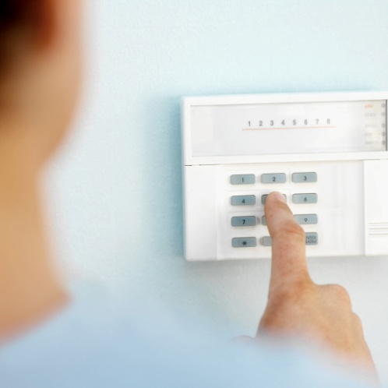
- Where is the alarm indicating the emergency exists?
This gives the location for action (evacuation), investigation, first response and attendance by emergency services.
You need to be able to identify (as appropriate):
- Department/s
- Floor/s
- Room/s.

Use of venue knowledge
Your knowledge of internal venue alarm types should assist in determining the meaning for various audible and visual alarms.
For example just by listening to an alarm you should be able to tell the difference between the fire alarm and an intruder alarm.
Just by looking at a flashing light or a panel light you should be able to tell whether the alarm is a smoke alarm or a gas alert.
You also need to know the different stages of each alarm (where applicable) – see section 2.3.

1.2 Contact emergency service providers

Introduction
It is a standard industry requirement the fire brigade must be called whenever a fire is suspected or detected.
Similar arrangements apply when other alarms are activated.
This section describes requirements and protocols for contacting the authority bin response to an alarm or emergency situation.

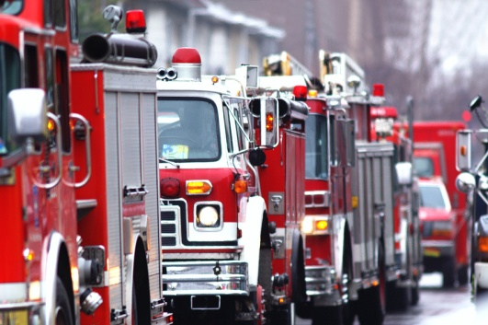
Basic requirements
The emergency services are:
- Fire
- Police
- Ambulance.
The fundamentals in relation to contacting emergency services will/may relate to using options available within the venue for emergency response – these may include:
- Make telephone contact (using landline phone or cell phone) with them as required by the type of alarm – for example:
- Fire alarm or smoke detector alert requires contacting the fire brigade
- Intruder alarm requires contacting police
- Use direct lines to authorities or security companies – some venues have dedicated lines linked directly to emergency services or a central ‘command and control’ remote site operated by an external security company
- Contact management – this relates to contacting your supervisor or the Duty Manager at the time.
The protocols which have been developed in the venue will then require that designated person to automatically contact emergency services as required by:
- The type/nature of the emergency
- The requirements of the EMP
- Activate an alarm – many of these will automatically contact/alert:
- A remote site – such as a control room, monitoring room or private security company
- Emergency services.

Making telephone contact with emergency services
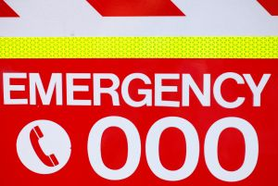
Telephone numbers
It is important to know the telephone numbers for all emergency services in advance.
You do not want to waste time when an emergency has occurred looking up the number.
The emergency telephone numbers for all emergency services should be:
- Posted in various locations throughout the venue – especially near telephones
- Entered into your cell phone
- Entered into speed-dialling facilities of landline telephones.
Be aware your emergency services telephone numbers may be:
- A national number – which can be called from any location/town/city in the country
- A set of local numbers – giving you direct contact with the nearest emergency services facilities/stations.
Reporting requirements
When telephoning emergency services to report an emergency you should:
- Identify yourself, position (bar attendant, Duty Manager, security staff) and venue location
- State you are reporting an emergency
- Describe the nature of the emergency
- Be guided by the operator on the other end of the phone – as to what to do and the information to provide
- Give the location of the emergency within the venue – Room number, Ballroom, cleaning cupboard on 2nd floor
- Identify the threat you believe is being posed – people trapped; building has collapsed
- Define the numbers of people threatened/involved
- Describe any local factors relevant to the emergency – power out; escaping gas; internal comms system not operational; venue very busy/crowded
- Advise of best approach or entrance to use
- Give your opinion regarding the action required
- Never hang up until told to do so.

1.3 Ensure access and assistance to emergency services upon their arrival

Introduction
It is standard practice in all venues to ensure, after emergency services have been called, someone is designated to meet those services on their arrival on-scene.

Meeting the emergency services
This means someone should be nominated to go outside the venue to the roadway/footpath to wait for the emergency services which have been called.
You may undertake this task yourself or delegate it to someone else.
Whoever does this job must:
- Know where the emergency is and know all the details available about the emergency
- Be able to quickly direct/lead the emergency workers to the emergency
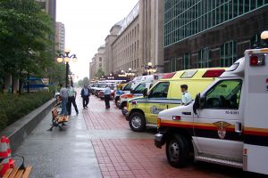
- Be able to provide information about the venue to the Officer-In-Charge, including information such as:
- Site plans
- Copy of relevant EMP
- How many people are in the building
- Where shut off valves and switches are
- What the layout of the property is
- Where potential dangers are located – such as gas tanks, petrol, flammable material
- Other factors impacting on the emergency – such as the presence/location of elderly people, children/babies, disabled people, trapped guests/workers
- Be someone in authority who is able to give orders/direction to staff.
Anyone who has been allocated the role of awaiting the arrival of the emergency services must understand this is a very responsible position.
You must not abandon this position to do something else.

Clearing the access route/s

Where possible, the expected access route for emergency vehicles should also be cleared as far as possible.
This may include:
- Moving establishment vehicles parked in front of the venue or in nearby parking areas
- Requesting others to move their vehicles
- Asking taxis to move
- Unlocking gates and barriers
- Preventing non-emergency vehicles from parking in the area you expect the emergency services vehicles to occupy
- Clearing away tables, chairs, fixtures and fittings
- Asking people to clear the area.
A properly prepared Emergency Management Plan will have factored these considerations into the allocated duties for staff.

Assisting as required
There may be a need to assist emergency workers in their efforts.
As a general rule, however, you should leave the professional emergency workers to do their work and not ‘assist’ unless specifically asked to do so: very often, unasked for ‘assistance’ is not only an annoyance but it can be dangerous and counter-productive.
When asked to help you should follow the following points:
- Indicate immediately whether you are prepared and/or able to help – if you feel you cannot do what you have been asked to do, say so immediately
- Clarify quickly (where necessary) exactly what it is you have been asked to do – so you know with certainty what is expected of you/what you are being asked to do
- Do it – do not waste time thinking about it
- When your assistance is no longer needed, ask if other help is required and if it is not move out of the area – if you are not helping, you are in the way.

1.4 Provide first response assistance

Introduction
All staff are expected to provide first response assistance in the event of an emergency.
This section identifies what this response might be and provides limitations which apply to its provision.

Recognition and action
All emergency and potential emergency situations should be promptly identified and the required action should be taken within the scope of the individual’s responsibility.
All venues should have an Emergency Management Plan (sometimes referred to as an Emergency Action Plan) to follow in the event of an emergency, and all staff members must be trained in its implementation.
It is vital you participate actively in all drills and practice sessions.
The Emergency Action/Management Plan will guide you but in other circumstances you will have to make on-the-spot decisions about what needs to be done based on:
- The circumstances which apply at the time
- The number of people in danger
- The type of threat
- Assistance available
- Resources/assets available.

Golden Rules
These have already been stated but they are so important it is necessary to re-state them.
If you are ever faced with an emergency situation, three Golden Rules apply:
- Never put yourself in harm’s way
- Always make sure emergency services are contacted as soon as possible
- Always put saving lives above saving property.

Generic responses
The first response assistance you provide must always be:
- Dictated by the training you have received
- Reflect the nature of the event/emergency being responded to.
The following generic requirements/responses apply for first responders:
- Follow the plan for responding to the situation if one exists:

- It is a workplace reality plans cannot be prepared for every possible risk, threat or emergency
- If time allows, access a copy of the plan to use a guide/reference – this highlights the need for you to:
- Know what the plans contain
- Know where they are physically located
- Respond immediately – this means:
- You must do not delay
- Do not procrastinate
- Do not over-think the situation
- Never feel you are over-re-acting
- Verify others have been notified – as already identified/described including emergency services, other staff and/or management
- Stay calm and composed – your action/response is vital in establishing the attitude/response of others: they will be looking to you for leadership:
- Do not panic or cause panic
- Do not shout – speak quietly and calmly
- Do not run around
- Take action to address the situation:
- Use common sense
- If safe to do so
- As prescribed by the relevant plan
- See below ‘Action to take’
- Continue to monitor the situation – and provide up-dates to the ‘command centre’ or relevant person/warden/manager.

Action to take
Acton will depend on the situation with examples including:
- Instructing other staff on action to take – including specification of what they should/must not do
- Initiating evacuation – or moving people to a safe area
- Activating alarms
- Restricting access to the affected area
- Closing doors and windows, turning of air conditioning
- Fighting the fire
- Knocking on doors/alerting room occupants
- Providing basic first aid
- Moving people/removing people from danger/the threat
- Re-locating items, stock, property, assets away from the threat
- Taking common sense action to limit damage
- Shutting off supply valves and taps – for gas
- Closing/locking doors and windows – to stop air flow to fires and to prevent access
- Opening doors and windows – to help disperse gas/fumes and to enable access by emergency services (as appropriate).

Fire fighting equipment
In-house training is essential before using ANY fire fighting equipment.
You must also make sure:
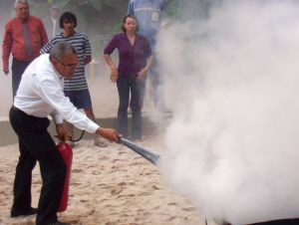
- You know how to differentiate between the different types of portable fire extinguishers – CO₂, dry chemical, water: their different colours is the quickest way to tell them apart
- You know what extinguishers can be used on what types of fires – never use water extinguishers or hoses on oil, fat or electrical fires
- You know how to operate the extinguishers effectively
- You know where the fire hoses are and how to operate them
- You know where sand buckets are located
- You know where the fire blankets are and how to use them.
Fire fighting equipment can include:
- Water extinguishers – suitable for use on ordinary combustible materials but not safe for use on electrical fires or cooking oil/fat fires.
They are ineffective and potentially dangerous on flammable and combustible liquid fires
- Foam extinguishers – dangerous if used on electrical fires.
They are suitable for ordinary combustibles and for fires featuring flammable and combustible liquids
- Powder extinguishers – can be used on ordinary combustibles, fires featuring flammable and combustible liquids and electrical fires.
- Carbon dioxide extinguishers are best for electrical fires – they have limited effectiveness on fires featuring flammable and combustible liquids, and cooking oil/fat fires
- Reels and hoses
- Fire blankets
- Sand buckets.

Chain of Command
Venues frequently develop a ‘chain of command’ as part of their planning when they prepare their Emergency Action/Management Plans.
The chain of command:
- Identifies position and responsibilities for action in the event of an emergency
- Allocates these positions to nominated staff
- Is developed to provide the best way for the venue to retain command and control over an emergency situation.
Roles and responsibilities
The following represents possible positions which may exist within a chain of command and identifies the roles and responsibilities which may attach to each position.
Chief Warden
In an emergency the Chief Warden should:
- Ascertain nature of the emergency and determine action
- Ensure the appropriate emergency service has been notified
- Ensure Area Wardens have been advised of the situation
- If necessary, initiate evacuation and controlled entry procedures
- Brief emergency services upon their arrival, on the type, scope, and location of the emergency, and the status of the evacuation
- Act on the senior emergency services officer’s instructions.
Deputy Chief Warden
In an emergency the Deputy Chief Warden shall assume the responsibilities normally carried out by the Chief Warden in their absence, or assist the Chief Warden as required.
Communications Officer
In an emergency the Communications Officer is responsible for:
- Ascertaining nature and location of the emergency
- Notifying appropriate personnel
- Transmitting and recording instructions and information between Chief Warden and Area Wardens and others
- Recording the progress of the evacuation and action taken by the Area Wardens.

Area Wardens
In an emergency Area Wardens should:
- Commence evacuation if circumstances in their area warrant it

- Implement the emergency procedures for their area
- Communicate with Chief Warden and follow instructions received
- Direct Wardens under their control to check area for any abnormal situation
- Advise Chief Warden of circumstances and actions taken
- Provide lists of people to be accounted for
- Confirm persons are accounted for.
Wardens
In an emergency Wardens may:
- Act as Area Wardens in their absence
- Notify the fire brigade or other emergency service
- Search the area to ensure persons are accounted for
- Ensure orderly evacuation to Evacuation Assembly Areas
- Assist mobility impaired persons
- Maintain control of persons at Evacuation Assembly Area
- Operate first attack fire fighting equipment if trained to do so.
First Aid Personnel
In an emergency, First Aid Personnel should:
- Report to the relevant Warden
- Assist the Warden with mobility impaired persons
- Render first aid to injured persons when safe to do so
- Communicate with the Area Warden regarding actions to be taken
- Record first aid actions taken.

Work Projects
It is a requirement of this Unit you complete Work Projects as advised by your Trainer. You must submit documentation, suitable evidence or other relevant proof of completion of the project to your Trainer by the agreed date.
  - Visit a hospitality venue and speak to a manager or the owner.
Ask them the following questions and submit a report based on their answers:
- What alarm system do you have?
- What does it detect/alert you to?
- How do you know when an alarm system has detected a problem?
- How can you determine where the problem is when the alarm makes you aware of the situation?
- What standard procedures apply when staff need to contact emergency services to request their attendance at the venue?
- What do staff do to prepare for the arrival of fire services in response to a call for help?
- What first response activities are staff trained to undertake to respond to fires on the premises?

Summary

Respond to fire and other alarms
When responding to fire and other alarms:
Respond promptly
Never assume an alarm is a false alarm
Identify nature and location of alarms
Notify others immediately – internally and externally
Get help moving your way as soon as possible
Put ‘notifying others’ and ‘obtaining assistance’ before taking other ‘first response’ action
Never put yourself in danger
Put safety of people before safety/security of property
Facilitate arrival and access of emergency services
Provide first response action in accordance with training, resources available and common sense.

Element 2:
Respond to safety threats

2.1 Manage patrons who are displaying inappropriate behaviour

Introduction
You will be required to manage patrons who are displaying inappropriate behaviour.
This section describes inappropriate behaviour and explains the action which may be taken.

Context
There is potentially quite a difference between what venues determine to be ‘inappropriate behaviour’.
One venue may be far more lenient than another in defining what is acceptable and what is not.
There is also potentially a variation between acceptable and unacceptable standards:
- Within the one venue – requirements in a bar may be different to requirements for behaviour in a restaurant; requirements in a night club will be different to acceptable standards at reception/in the main foyer or lobby area
- At different times of the day – the requirements in the same area can be quite different at 10:00PM than they were at 10:00AM.

Examples of inappropriate behaviour
Inappropriate behaviour may include:
- Aggressive, rude and anti-social behaviour by patrons or members of the public who are on the premises

- People arguing with other patrons or staff
- Patrons/people who refuse to leave the premises when asked to do so
- Patrons/people who are intoxicated on the premises
- Anyone who intimidates, or attempts to intimidate, anyone on the premises
- Any person committing an act of violence in the venue
- People who swear or use any form of abusive language – including racist and/or sexist terms
- Customers who fail to meet required dress codes for certain parts of the venue
- Rooms in which there are ‘too many’ guests – for example, a room sold for two people but where evidence exists there are more than this sleeping in the room
- Noisy patrons.

Ways to respond
Whenever a sign of a problem is identified you must be proactive in addressing it, which may include:
- Moving closer to the ‘situation’ and looking in the direction of those involved
- Having a word with those involved and asking them politely to modify their behaviour/language
- Escorting persons away from the area or out of the venue
- Advising patrons of what is expected and acceptable
- Communicating with control/supervisor and informing them of developments including:
- Seeking permission to act
- Seeking advice on what to do
- Requesting back-up.

Another ‘Golden rule’
The golden rule in relation to managing patrons who are displaying inappropriate behaviour is all potentially troublesome situations must be 'nipped in the bud’.
This means no situation should be allowed to go un-checked or un-addressed if it has the potential for harm, offence, and abuse or contravenes the venue standards for suitable/acceptable behaviour.
It is vital you realise in a public situation you and everything you do, or do not do, is on public show: if you allow one person to ‘get away with something’ you are automatically sending a message to the others who see or hear this they can get away with it too.
When you intervene to control a situation you are similarly sending a message to everyone that such behaviour or language will not be tolerated.

‘Hearsay evidence’
It is standard industry practice not to act on hearsay evidence when responding to a complaint about unacceptable patron behaviour/language.
Hearsay evidence is allegations or assertions made by customers that certain things happened such as:
- A person jumped the queue
- A person used bad or offensive language
- A person was rude
- A person committed an offence.
Most venues will require you to have first-hand evidence something has occurred (that is, they will require you actually saw or heard it yourself) before they will authorise you to take action.


You are not a police officer
It is extremely important you understand performing security or safety-related work in a venue does not make you a police officer.
You do not have the same rights as a police officer.
You do not have the same right to stop people or to demand their name. You may, of course, request it/ask for it but people do not have to comply.
Your rights as a security officer are, in reality, no more than the rights of the ordinary citizen.
Your ‘power’/’authority’ often comes from:
- The fact you are in uniform – and most people respect the uniform
- Your demeanour/attitude and appearance – and sometimes your size.

Making an arrest
The brief advice is – Don’t!
Making a citizen’s arrest may look and sound fine on the television, but that is not the reality of most situations.
There is too much that can go wrong – from physical violence and assault through to possible legal action for wrongful arrest/detaining a person against their will (or similar).
If an arrest is required or there is a need to detain a person you must be very careful you can:
The best advice is to ‘delay’ the person (the alleged offender) from leaving until the police arrive and then letting them deal with the situation.
Discuss this with your venue and be guided by them and specific house policy.
Strategies to delay ‘offenders’ until police arrive can include:
- Engaging the person in conversation
- Asking them questions
- Providing them with a drink or something to eat
- Asking them to wait for the police to arrive.
The reality of many security and safety-related jobs is, if a problem occurs, your job is to:
- Contain the situation to the best of your ability – by, for example:
- Moving people away from the situation
- Restricting access to an area
- Call for assistance from external security or local authorities
- Protect and defend – always put the protection of lives/people above the protection of assets/physical resources (including cash).


2.2 Make safe areas that are identified as being unsafe

Introduction
As you respond to identifies safety threats you are also expected to make safe any areas identified as being unsafe.
This section defines ‘unsafe’ areas and lists the standard actions to take to make these areas safe.

Unsafe areas
Definition
Unsafe areas are:
- Areas which pose a risk to the safety of people – including:
- Guests/customers
- Members of the public
- Staff
- Areas which, if left as they are, may cause damage to:
- The venue
- Assets and/or property.
Examples of unsafe areas
Unsafe areas can include (but are certainly not restricted to) the following:
- Areas where people are fighting or engaging in threatening or otherwise potentially dangerous behaviour
- Situations where the building presents a danger – such as:
- Broken windows
- Spilled liquids on the floor
- Items which have been dislodged and are in danger of falling
- Machinery of equipment which is malfunctioning and creating the potential for explosion, fire or other injury
- Circumstances where the weather or local environment presents a threat – such as:
- Excess wind
- Rain coming into the building
- Smoke from a nearby fire
- Fumes from a chemical spill which is close by
- Emergency situations which create an unsafe area – such as:
- Fire in a room – or on a floor
- Gas leak in the kitchen with impact on the associated dining areas
- Riots in the street outside the venue.

Action to take
Where you are first on the scene at a situation where there are unsafe areas you should:
- Immediately report back on what you have found – advising:

- Location and nature of the problem
- Cause of problem – if known
- Possible impact – in terms of:
- People likely to be impacted
- Nature of the impact
- Impact site/s
- Seek assistance/notify the relevant person where necessary – to:
- Get assistance moving towards you
- Initiate any programmed internal response – such as implementing an Emergency Management Plan for the specific type of issue which has been identified
- Determine if there is need to activate an alarm
- Make safe unsafe areas to the best of your ability as possible ‘at the time’ – by taking basic actions such as:
- Closing/locking doors, windows and/or rooms
- Erecting barricades to prevent access
- Restricting access to unsafe areas by directing people elsewhere away from the danger and out of harms’ way
- Directing people to move away – and advising where to go and how to get there
- Physically removing dangerous items – only where this is totally safe to do so
- Remaining in place to provide a physical presence/deterrent – and to stop people entering the dangerous/unsafe area
- Turning on lights – to:
- Deter people who should not be there
- Give people light by which to see where they are going.

2.3 Respond to suspicious packages

Introduction
All ‘suspicious packages’ must be responded to appropriately.
This section presents considerations for effective responses.

Context

Today venues are more aware of the possibility of terrorist activity than ever before.
This means staff should be aware of any packages:
- Left lying around
- Unattended
- In a place they should not be.
Always err on the side of caution when you think you have identified a suspicious package and never be afraid of:
- Notifying management – and getting a supervisor/manager involved in the situation
- Clearing people away
- Contacting the authorities.

Action to take
Where a suspicious package is identified, the appropriate response is:
- Do not touch it – leave it alone
- Make immediate local enquiries to see if you can identify the owner – the owner may have just wandered away, be speaking to staff at reception or be at the bar obtaining a drink
- Phone the police and report the finding – stay on the line until told to hang up: answer the questions asked to the best of your ability.
Internal requirements may you to notify management first: adhere to venue policy in this regard
- Evacuate people from the immediate area – you may elect to evacuate people from a wider area depending on the nature of what you have found
- Turn off anything likely to trigger an explosion, such as mobile phones, pagers, electronic devices.

Additional points to consider
It is worth bearing the following in mind in relation suspicious packages:
- There is no such thing as a definition of a suspicious package – many items which do not look suspicious have, in fact, concealed a device that has exploded
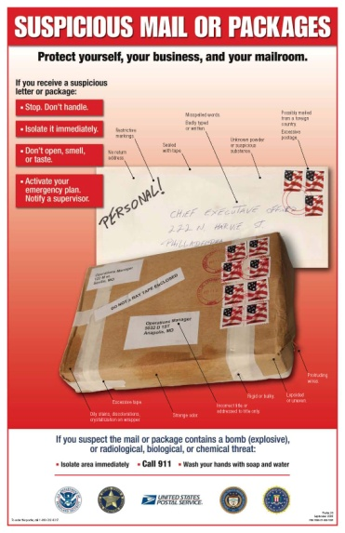
- There are indications a package may conceal a device – and experts know what to look for. You are not an expert.
The problem is if you examine a package and believe it has no tell-tale signs it is a bomb, you may move it and by so doing, detonate it.
It is for this reason these notes have deliberately omitted information about what signs to look for.
You are urged to treat every suspicious package with the utmost care and respect: follow the advice given above
- When the police have been notified, they will attend and assist with evacuation, as well as determining which other services should be called in
- While you do not want to overreact to suspicious package situations, it is important to make the decision relatively quickly about whether or not 'a situation' exists.
Commonly individuals are reluctant to contact authorities in case there is not a problem, and they think they will then be made to look foolish – you must overcome this thought.
It really is a case of being better safe than sorry
- To get the optimum results from a bomb, terrorists rely on:
- Your lack of observation to detect the package
- Your reluctance to act.

2.4 Respond to bomb threats

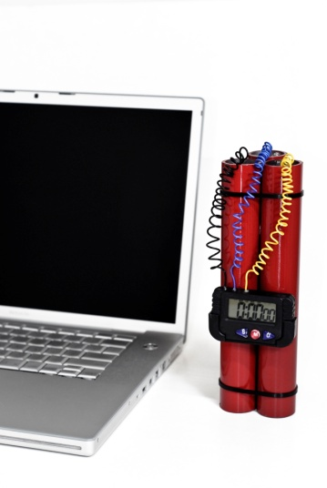
Introduction
Bomb threats are certainly not a common occurrence but it is important you respond effectively and efficiently if one is received.
This presents accepted responses to a bomb threat.

Pay attention, ask questions and take notes
(The following notes are based on information provided by the Australian Federal Police.)
When you receive a bomb threat over the telephone, handle the call calmly.
Make sure you listen attentively for issues which may help identify the caller and/or the location from where the call was made.
Venues may provide a ‘Bomb Threat Checklist’ near telephones to assist in this regard.
See http://safety.unimelb.edu.au/docs/AFPbombchecklist%20New.pdf for sample ‘Phone Bomb Threat Checklist.
Call details
Pay attention to:
- Background noises – which may relate to:
- Street and/or house noises
- Aircraft noises
- Music
- Other voices
- Machinery
- Details about the caller – such as:
- The caller’s accent
- Gender
- Age
- Speed they spoke at
- Speech impediments
- Diction
- Call details – for example:
- Was it real-time or taped?
- Was it read from a script or made up on-the spot?
- Threatening?
- Abusive?
- Rational?
- Incoherent?
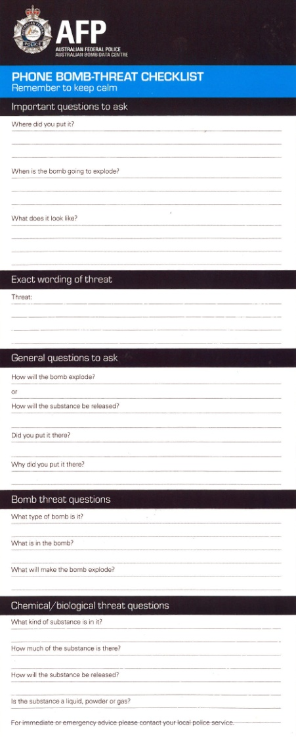
Bomb details
Ask questions to try to get as much information from the caller as you can:
- ‘What does the bomb look like?’
- ‘What type of bomb is it?’
- ‘What is in the bomb?’
- ‘When is the bomb due to explode?’
- ‘Why did you plant the bomb?’
- ‘How can we defuse it?’
- ‘What will make the bomb explode?’

After taking the call
After the call, immediately speak with the appropriate person about the threat.
Talk in a quiet place away from others.
Communicate the details in a calm and clear manner – to avoid panic.
Refer to details captured on the Bomb Threat Checklist.
Immediately start evacuation procedures.
Never think the call was a hoax – it is not worth risking lives if your thinking was wrong (see below).

Genuine emergency or hoax?
There may well be times where you are faced with a decision – ‘Is this a hoax, or is this genuine emergency?’
The golden rule is:
“It’s always a genuine emergency.”
It is not your job to determine, for example, whether or not a bomb threat is a hoax.
Your job is to:
- Know what house policies are in these situations
- Implement them immediately.
It is up to others to decide if the situation is real or not.
Remember, the first three minutes are vital: three minutes wasted wondering about whether something is genuine or not can result in the deaths of many people. You can evacuate a lot of people in three minutes.
Also, remember guests will not be impressed when they find out – and they always do find out – there was a bomb threat when they were there but the establishment did nothing about it: they will feel their safety and security was not taken seriously, and they might not return.
Let the police, or management, decide if it is a hoax or not.
Work Projects
It is a requirement of this Unit you complete Work Projects as advised by your Trainer. You must submit documentation, suitable evidence or other relevant proof of completion of the project to your Trainer by the agreed date.
2.1 A group of foreign tourists are drinking in a bar in the venue and are being very noisy. Some of them appear intoxicated.
They are guests in the house.
Prepare a submission describing how you would deal with this situation.
2.2. You have noticed a broken plate glass window in the front of one of the shops in the lobby/retail area of the venue.
Prepare a submission describing how you would deal with this situation in order to maintain the safety of premises and personnel and optimise the likelihood of these returning to the venue to spend more money at a later date.
2.3. It is 11:30PM and the reception area of the hotel is completely empty of guests.
You notice an unattended box covered with brown paper and sealed near the piano in the lobby.
Prepare a submission describing how you will respond to this situation.
2.4. Prepare and submit a Checklist suitable for placement in the workplace to inform staff about:
- How to deal with an incoming telephone call advising there is a bomb in the building
- Action to take after the ‘bomb threat’ telephone call has been received.

Summary

Respond to safety threats
When responding to safety threats:
Respond promptly – nip problems in the bud
Obtain first-hand information wherever possible
Be proactive
Remember you are not a police officer
Avoid making arrests
Never put yourself in danger
The safety of people takes priority over safety of property
Make safe all unsafe areas
Limit any adverse impacts or damage
Respond positively to suspicious packages
Treat all bomb threats as genuine.

Element 3:
Respond to emergency situations

3.1 Identify the nature and scope of the emergency


Introduction
When faced with an emergency it is necessary to first identify the nature and scope of the situation.
This section identifies issues in this regard.

Need for this step
Whenever you respond to an emergency, part of your first response must be to determine the nature and extent of the emergency.
This is necessary so you can:
- Pass on correct information to others – staff, guests and emergency services
- Determine the most appropriate course of action to take.
The hospitality industry is a unique industry – it is often operational twenty-four hours/day, seven days a week; it is open to the public and it commonly has numerous people (guests, workers, visitors, delivery people, and service technicians) on the premises.
All this plus it is an environment where:
- People consume alcohol
- Guests are often in an unfamiliar environment
- Guests may be asleep when the emergency arises.
In addition, many venues are spread over quite large areas featuring:
- Outside public areas - car parks, gardens, pools, walkways, entertainment areas
- Numerous internal spaces – bars, guest rooms, function rooms, entertainment areas, spa facilities, gymnasiums, pools, kitchens, dining areas, offices, store rooms
- Multi-level buildings.
All of these factors combine to produce a situation where almost any type of emergency could arise.
This is distinctly different to many other industries where they are able to more clearly identify a more limited range of emergencies that could occur.

Nature of the emergency
The different types of emergencies (which have already been identified) could include, but are not limited to:
- Fire – in a public area (internally or externally), in a kitchen, in the ironing/linen room, in a guest room
- Medical emergency – such as the collapse of a guest, an injury to staff or guests caused by an attack
- Gas leak – related to cooking, heating or other appliances giving rise to the possibility of explosion and/or fire
- Bomb threat – creating a situation where most establishments will automatically initiate a full evacuation of the premises and the involvement of emergency services
- Hostage situation – necessitating the involvement of authorities and the removal of all those who have not been taken hostage to a safe location
- Chemical spill – which may create a situation posing a risk from toxic fumes and the danger of burns due to contact with the chemical, explosion and/or fire
- Robbery – this includes a robbery committed against the establishment as well as robberies committed against guests and staff
- Deranged customers – which can include patrons who are intoxicated, those who may be affected by drugs or those who are simply being extremely difficult to deal with perhaps because of other issues (such as tiredness, unfamiliarity with their surroundings, lack of money, relationship problems, gambling problems)
- Flood – which can be caused by a burst water main, or may be the result of a natural event such as a cyclone, very heavy rain or a hurricane or typhoon
- Power failure – a power failure provides the potential for many emergencies: in itself the power failure rarely creates an emergency but it can produce circumstances making it more likely other emergencies will arise such as people trapped in elevators, thieves who take the opportunity to commit a crime because they believe there is less chance of being caught, guests slipping or tripping because there is insufficient light to enable them to see properly.
The Emergency Management Plan should have investigated possible emergencies identified as being likely to occur and taken appropriate planning action for each of them.

Scope of the emergency
Every emergency is different.
It is vital you try to assess the extent of any emergency as quickly as possible but this should not stop you from summoning help as soon as possible.
For example, you may notice smoke coming from under a closed door to a store-room and decide it is nothing too serious: you believe the sprinkler system will deal with it, and believe the automatic sensors will have detected the fire and notified the authorities. If the store is in the basement and surrounded by concrete walls then perhaps you may notify Reception or Security of the smoke, but not initiate an evacuation of the establishment.
On the other hand, if you noticed the same situation on the 5th floor of an accommodation hotel at 3:00AM your response will be totally different.
Critical factors in deciding what the extent of the emergency is can include consideration of the following questions:
- How many people are in danger/likely to be affected? All lives are valuable, but the more people who are potentially affected, the more urgent the situation and the greater the extent of the emergency
- Who is available to help you – immediately? If most of the staff are away (such as on night shift) and there is little in the way of immediate support within the establishment, the more urgent the situation and the greater the extent of the emergency
- What is the possibility of you being able to deal successfully with the situation on-the-spot (after notifying others of the problem)? If you believe the emergency is too big for you to deal with, the more urgent the situation and the greater the extent of the emergency
- What are others doing? You may notice a situation where others are working to address the emergency and appear to be succeeding, but you may also notice everyone just appears to be standing around watching what’s going on despite the imminent danger to themselves
- How are other behaving? Where people appear to be, for example, evacuating effectively and quickly in a quiet and orderly fashion this a vastly different set of circumstances to a situation where they are rushing about in panic, returning to their rooms to collect personal belongings when there is a fire, or standing in the one place crying
- What are other associated factors that could make the situation worse? If there is a fire next to a gas tank this is more serious than a rubbish bin on fire next door to the outside swimming pool. If the wind is blowing in your direction and the place next door is on fire, this would also be a concern, or if you know all the guests on the top floors are frail and elderly people (or children) this poses more of a problem than if they were fit, young athletes.
The key to determining the full extent of the emergency in a venue is therefore to obtain as many relevant facts about the situation as you can, and use those facts together with your knowledge of the establishment (location of equipment, layout, available staff) and common sense to make a decision.
It is always best to adopt a ‘worse case’ scenario.
You are better off calling fire authorities for a small fire you manage to extinguish yourself before they arrive, than delaying placing the call for help and having the venue burn to the ground.

3.2 Contact emergency services

Introduction
In the same way emergency services need to be contacted to respond to fire and other alarms, so too will they often need to be contacted as part of your response to emergency situations.
This section essentially duplicates information provided in section 1.2.

Basic requirements
The emergency services are:
- Fire
- Police
- Ambulance.
The fundamentals in relation to contacting emergency services will/may relate to using options available within the venue for emergency response – these may include:
- Make telephone contact (using landline phone or cell phone) with them as required by the type of alarm – for example:
- Fire alarm or smoke detector alert requires contacting the fire brigade
- Intruder alarm requires contacting police
- An alert regarding guest illness or assault requires contacting ambulance
- Use direct lines to authorities or security companies – some venues have dedicated lines linked directly to emergency services or a central ‘command and control’ remote site operated by an external security company
- Contact management – this relates to contacting your supervisor or the Duty Manager at the time
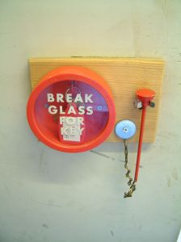
The protocols which have been developed in the venue will then require that designated person to automatically contact emergency services as required by:
- The type/nature of the emergency
- The requirements of the EMP
- Activate an alarm – many of these will automatically contact/alert:
- A remote site – such as a control room, monitoring room or private security company
- Emergency services

Making telephone contact with emergency services
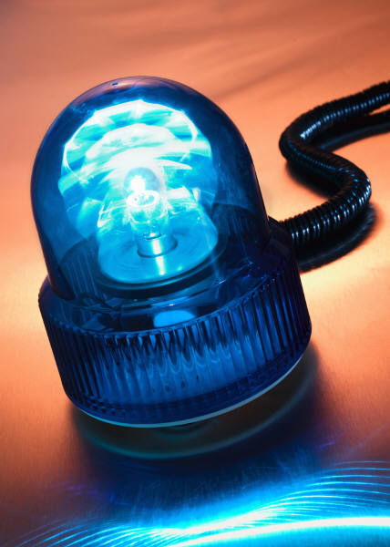
Telephone numbers
It is important to know the telephone numbers for all emergency services in advance.
You do not want to waste time when an emergency has occurred looking up the number.
The emergency telephone numbers for all emergency services should be:
- Posted in various locations throughout the venue – especially near telephones

- Entered into your cell phone
- Entered into speed-dialling facilities of landline telephones.
Be aware your emergency services telephone numbers may be:
- A national number – which can be called from any location/town/city in the country
- A set of local numbers – giving you direct contact with the nearest emergency services facilities/stations.
Reporting requirements
When telephoning emergency services to report an emergency you should:
- Identify yourself, position (bar attendant, Duty Manager, security staff) and venue location
- State you are reporting an emergency
- Describe the nature of the emergency
- Be guided by the operator on the other end of the phone – as to what to do and the information to provide
- Give the location of the emergency within the venue – Room number, Ballroom, cleaning cupboard on 2nd floor
- Identify the threat you believe is being posed – people trapped; building has collapsed
- Define the numbers of people threatened/involved
- Describe any local factors relevant to the emergency – power out; escaping gas; internal comms system not operational; venue very busy/crowded
- Advise of best approach or entrance to use
- Give your opinion regarding the action required
- Never hang up until told to do so.

3.3 Implement the Emergency Management Plan for the premises

Introduction
You are expected to discharge your allocated responsibilities as set out for your position in the EMP for the venue.

This section addresses what these requirements might be.

Important pre-requisites
In order to follow the EMP (or Emergency Action Plan) you must:
- Obtain, read and understand the plan for your position
- Query/clarify any points which are unclear
- Talk to others about their roles and responsibilities
- Participate in EMP training sessions
- Participate in venue emergency and evacuation drills and practice sessions.

Adhering to EMP requirements
The EMP must provide the basis for your action/response however you are expected to use common sense where the plan cannot be adhered to and/or when circumstances dictate.
Where you have to vary the action/response taken:
- Seek approval for the action, if possible, before taking it
- Always seek the greatest good for the greatest number
- Notify the chain of command about what you intend/have done.

Activating alarms and notifying emergency services
This has already been covered in much detail but it is extremely important.
Many disasters have occurred because everyone thought someone else had taken this step.
When an emergency situation has been identified, speed in responding is critical.
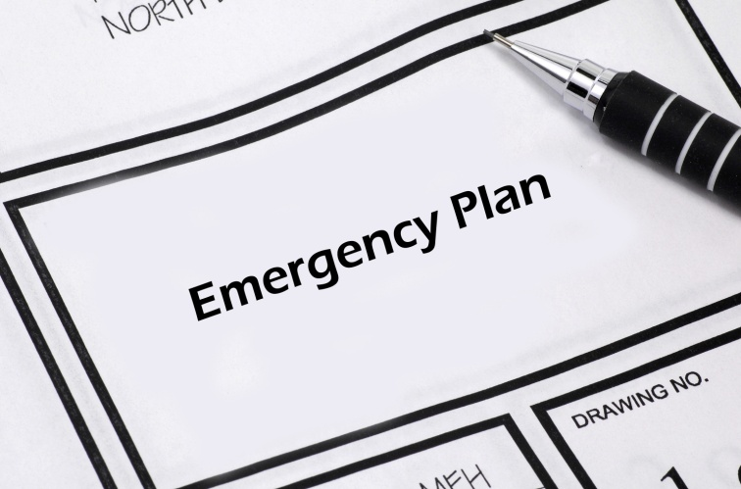
The biggest problem with responding effectively to an emergency lies in the first one or two minutes when staff waste time determining whether or not they need to do something, and/or working out what they should do.
It is essential to act/respond quickly by:
- Activating an alarm
- Contacting a nominated internal person
- Notifying external authorities.
As soon as you have done this you must then:
- Implement your role in the EMP
- Assist others
- Engage in first-attack response where safe to do so
- Evacuate people to the designated Evacuation Assembly Points.


Wearing designated clothing
Your uniform will serve as an indicator you are an employee of the venue and this gives some initial status as someone ‘in charge’ and able to give directions to people when an evacuation is required.
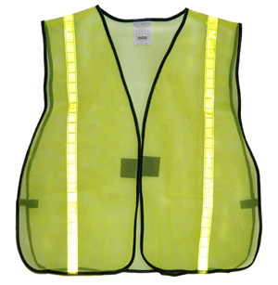
In addition, you may be required to wear:
- A nominated hat – different colours indicate the role of the person wearing it
- A coloured vest with your role written on the vest.
This indicates to both members of the public, other staff and emergency workers what your role – and hence your potential knowledge, skills and abilities may be.

Complying with chain of command
Your role is to not only follow the actions prescribed for you in the EMP but also comply with chain of command directions during the emergency:
- Promptly
- Completely
- Without question – see ‘Questioning command directions’ below.

Providing clear instructions to guests
When giving instructions to guests in an emergency situation the requirements to follow are:
- Ensure you know what you are talking about
- Speak clearly and calmly but with authority – speak as if you expect people to comply with what you say
- Do not panic
- Try not to yell
- Exude confidence
- Repeat yourself often/as necessary
- Use appropriate sign language and signals
- Be prepared to ‘show’ and not just ‘tell’.

Responding to and communicating changing circumstances
An emergency is a dynamic situation.
Your role is to notify command of the changes and alter your response to suit the changed circumstances.
Changed circumstances may be:
- A variation in the environment/atmospheric conditions
- An increase in the number of people involved/impacted
- Failure or success of the first-attack/first response to address the cause of the emergency
- Unexpected behaviour of:
- People – such as panic, failure to obey directions
- Resources – such as lack of resources, failure of resources, inappropriate resources)
- The emergency situation itself – unexpected spread of fire, gas or fumes; explosion).

Questioning command directions
You must use common sense when dealing with emergencies.
So how does this sit with following instructions from the chain of command when you think/know those instructions are not the best course of action?
Simple!
You follow what common sense tells you to do based on your first-hand, on-the-ground knowledge:
- Explain to the person giving the direction why you think their instruction is flawed/unsafe
- If the chain of command knows about the information you have supplied you are expected to do what they say unless you firmly believe it will put your safety or the safety of others in danger.

Placing safety of persons above security of property
In every emergency situation the safety of people must take priority over the safety of assets.
This means, for example:
- Fighting a fire must wait until all people have been rescued from rooms or evacuated from the area
- Saving an animal must take second place to saving a person or evacuating people
- Retrieving a vehicle must never take precedence over protecting people.

Assisting emergency services workers
When emergency services arrive on scene, they take over command of the situation.
If you are able to assist emergency services you must:
- Ignore the requirements of the EMP at their direction
- Follow directions given by emergency service professionals
- Alert them to any relevant special training/experience you have
- Be prepared to leave if you find you cannot accommodate the stated needs of the emergency services workers – for everyone’s sake you are better off out of the area under these conditions
- Be prepared to act as ‘support’ rather than first-line providers.

3.4 Provide first response assistance

Introduction
In the same way a fire can trigger the need to provide first response assistance so too the same requirement can apply when another type of emergency arises.
This section provides generic examples of the first response assistance which may be provided and repeat parts of, and must be read in conjunction with, section 1.4.

Generic responses
The first response assistance you provide must always:
- Be dictated by the training you have received
- Reflect the nature of the event/emergency being responded to.
The following generic requirements/responses apply for first responders:
- Follow the plan for responding to the situation if one exists:
- It is a workplace reality plans cannot be prepared for every possible risk, threat or emergency
- If time allows, access a copy of the plan to use a guide/reference – this highlights the need for you to:
- Know what the plans contain
- Know where they are physically located
- Respond immediately – this means:
- You must not delay
- Do not procrastinate
- Do not over-think the situation
- Never feel you are over-re-acting
- Verify others have been notified – as already identified/described including emergency services, other staff and/or management
- Stay calm and composed – your action/response is vital in establishing the attitude/response of others: they will be looking to you for leadership:
- Do not panic or cause panic
- Do not shout – speak quietly and calmly
- Do not run around
- Take action to address the situation:
- Use common sense
- If safe to do so
- As prescribed by the relevant plan
- See below ‘Action to take’
- Continue to monitor the situation – and provide up-dates to the ‘command centre’ or relevant person/warden/manager.

Action to take
Acton will depend on the situation with examples including:
- Instructing other staff on action to take – including specification of what they should/must not do
- Initiating auxiliary power/generators
- Recording the situation
- Physically assisting guests/patrons as required
- Providing advice, information and directions
- Conducting searches
- Performing rescue duties
- Initiating evacuation – or moving people to a safe area

- Confirming areas have been cleared/are free of people
- Activating alarms
- Knocking on doors/alerting room occupants
- Providing basic first aid
- Moving people/removing people from danger/the threat
- Taking common sense action to limit damage
- Shutting off supply valves and taps – for gas
- Turning off power
- Closing/locking doors and windows – to stop air flow to fires and to prevent access
- Opening doors and windows – to help disperse gas/fumes
- Preparing for arrival of emergency services
- Assisting and complying with directions from emergency workers.

3.5 Maximise safety of personnel during the emergency

Introduction
A vital part of responding to emergency situations is to maximise the safety of personnel during the emergency.
This brief section presents actions which may need to be taken to achieve this objective.

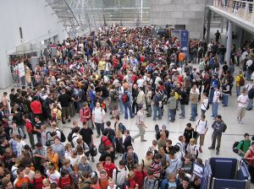
Action to take
‘Personnel’ includes:
- Guests and customers
- Staff
- Members of the public
- Anyone on the premises – which may include:
- Delivery drivers
- Service technicians
- Contractors
- Visitors.
Acton to maximise safety of personnel during an emergency may require you to:
- Never putting yourself in danger – you have an obligation to yourself and others to keep yourself safe
- Making the safety of people takes priority over the safety/security of people’s belongings or venue assets
- Containing the situation – by taking whatever action is appropriate to maintain safety of personnel while limiting the spread of the problem and/or reducing its impact on the venue
- Restricting access by people to the affected area (which may require the use of ‘reasonable force’) – by:
- Closing doors, gates and barriers
- Locking doors and access
- Putting ‘Do Not Enter’ or ‘Do Not Cross’ tape in place
- Erecting barricades
- Controlling access and exit points – to make sure only authorised persons gain entry. ‘Reasonable force’ can be used to do this.
- Mixing with, moving amongst and talking to guests/members of the crowd – to:
- Provide information and give directions
- Reassure them

- Keying off elevators – so people cannot use them

- Reversing the direction of escalators – to limit the access people have between floors
- Providing a physical presence – which will deter people from engaging in illegal or unwanted activities
- Verbally directing people – about:
- Where they can and cannot go
- What they can and cannot do
- Using loud hailer/megaphone or PA system to assist with providing information/direction
- Obtaining additional staff to assist with requirements.

Work Projects
It is a requirement of this Unit you complete Work Projects as advised by your Trainer. You must submit documentation, suitable evidence or other relevant proof of completion of the project to your Trainer by the agreed date.
3.1 Interview a suitable person in the industry, ask them the following questions and prepare a report detailing their responses:
- What protocols are in place at the venue for identifying when an emergency situation (other than fire) exists?
- What communication/notification occurs when an emergency has been identified?
- What do you consider when determining the nature and scope of the emergency?
- What emergencies do you have EMPs prepared to respond to?
- Identify one emergency situation you have an EMP for: what is the venue planned response to this emergency?
- What first response assistance can your staff provide in response to an emergency?
- What action do your staff take to maintain the security of the venue during an emergency situation?

Summary

Respond to emergency situations
When responding to emergency situations:
Never put yourself in danger
Establish the nature and scope of the emergency
Contact the emergency services as appropriate
Notify internal personnel as required
Make sure you have participated in emergency and evacuation training and drills
Implement relevant EMP
Activate alarms as appropriate/necessary
Use common sense
Adhere to chain of command protocols
Respond quickly
Give clear directions to guests
Safety of people takes priority over property
Perform search and rescue tasks
Take action to maximise safety of personnel during an emergency
Regular and effective communication is critical.

Element 4:
Conduct evacuations

4.1 Adhere to the requirements of the internal Emergency Management Plan for the premises

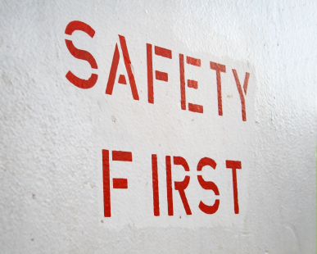
Introduction
When an emergency situation arises you are expected to implement the EMP for the premises.
This section details the role of Emergency Management Plans and explains the requirements and responses which these plans provide for.

Background to EMPs
EMPs provide the basis for practising and conducting appropriate responses to emergencies including evacuations.
For EMPs to be relevant to individual workplaces, specific workplace factors must be identified and integrated into the sample plans/direction provided in these notes.

Basic requirements
The directions given in the EMP must be the basis for action when responding to any emergency.
Where these cannot be implemented use your common sense to determine what to do. See ‘Emergencies for which no EMP exists’ (below, this section).
Emergency defined
An emergency is:
- Unforeseen – that is, not expected right ‘now’ even though it may have been anticipated ‘at some time’
- A threat – to people’s lives and/or property
- Something that requires immediate response – to protect lives and property.

Types of EMPs
It is possible your venue has created EMPs for the following:
- Terrorist attack
- Immediate personal threat situations – where staff feel threatened by customer/s
- Assault emergency
- Fire emergency
- Gas leak emergency
- Medical emergency
- Bomb threat
- Suspicious package
- Hostage situation
- Chemical spill
- Deranged customer
- Flooding
- Robberies or armed hold-ups
- Earthquake.

Role of the plans
The roles of the plans are to:
- Guide action in the event of an emergency
- Indicate the sequence of actions to be taken
- Allocate individual roles and responsibilities for taking action
- Provide contact details of individuals and external organisations who may need to be involved
- Prescribe evacuation routes and assembly points.
Non-negotiable, standard requirements
In all situations:
- Follow the EMPs for your workplace where they differ to what is presented in these notes
- Always put saving of lives before saving of property
- Never respond in a way that is dangerous for you or others
- Get help and notify others immediately – for example:
- If you have to decide between contacting the fire brigade or fighting the fire, contact the fire brigade
- If you have to decide between addressing an issue or contacting the authorities, contact the authorities or a designated person within your organisation.

The four basic requirements
Most emergencies require an evacuation of the venue, but this is not the case in every emergency.
When a decision has been made to evacuate the property, you must take four basic and critical actions in the following order/sequence:
- Activate the ‘evacuate now’ alarm
- Notify emergency services
- Notify designated internal personnel
- Notify and assist guests/patrons.

Activating the alarm
This may require:
- Pushing a button
- Breaking alarm glass and pushing or pulling a button, pulling a lever/handle or flipping a switch
- Telling another person (by telephone or face-to-face) to activate the alarm.

Notifying emergency services
Many alarms will automatically notify some emergency services – for example, activating a fire alarm in the venue will commonly activate an alarm in the fire station.
You need to know what applies in your workplace.
It is best to assume there is always a need to personally call the emergency services – you need make only one call to emergency services and they will advise other emergency services: you do not need to make a separate call to (for example) the fire service, police and ambulance.
Planning and preparation
The best course of action is to know where you can get help:
- Read your EMP and become familiar with it
- Speak to your supervisor and get them to tell you who you should contact in an emergency
- Find out where the list of telephone and other contact details for each of the emergency services is kept
- Workplace training and drills will assist.
Telephoning emergency services
When making initial contact with Emergency Services to obtain help they will require information about the incident before they send assistance:
- Tell them you want to report an emergency
- Be guided by them – let them ask questions and answer them as required
- Speak clearly and calmly
- Never hang up the telephone until directed to do so.
Emergency service telephone operators will want information about:
- The exact location of the emergency/venue
- Type of emergency – fire, hostage, gas leak
- The number of people involved
- Number of casualties and types of injuries.
While authorities will prefer to have all of the above information never delays calling them just because you are missing some of the information they will ask you about.
Always contact them and get them moving towards you.

Notifying designated internal personnel
Always follow the directions of your EMPs in this regard.
When making contact with designated internal personnel/management regarding an emergency/evacuation situation:
- Identify yourself, position and location
- State you are reporting an emergency
- Describe the nature of the emergency
- Give the location of the emergency
- Identify the threat you believe is being posed
- Define the numbers of people threatened/involved
- Describe any local factors relevant to the emergency
- Give your opinion regarding the action required
- Do not cease communication with this appointed person until instructed to do so.

Notifying and assisting guests/customers
Commonly the alarm already activated will be audible to guests.
In addition you may need to (in accordance with your workplace EMP):
- Telephone nominated guest rooms to advise guests
- Visit nominated areas, floors, rooms, offices, departments or other locations to verbally advise people
- Stand in a designated location and use a loud hailer or megaphone to notify people
- Knock on guest room doors
- Inspect and check nominated areas – saunas, toilets, staff rooms
- Escort people from an area
- Show people where to go – evacuation routes and assembly points
- Assist disabled people
- Urge people to comply with the need to evacuate
- Encourage people to leave belongings
- Place the safety of people above the saving of assets, protection of property and securing of cash.

Sample EMP contents for responding to a terrorist attack
The type of attack will determine the exact nature of the response.
Attack may be via chemical weapon, bomb, firearms or other means.
The EMP should include the following:
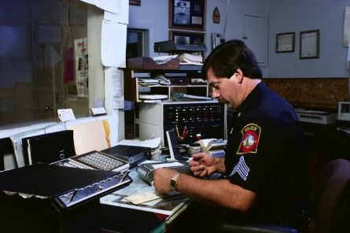
- Notify venue security – who will notify authorities
- Implement evacuation procedures
- Shut down equipment and power
- Notify neighbouring properties
- Maintain communication with security or CCC room
- Leave dedicated responses to the professionals.

Sample EMP contents for responding to an immediate threat situation
When faced with an immediate personal threat the EMP should provide that staff:
- Comply (do not resist the offender; do not delay compliance) with instructions given by offender as quickly as possible
- Notify security as soon as safe to do so
- Retreat if possible
- Take necessary action to end the situation – which may include:
- Apologise to offender
- Follow directions given
- Hand over money/assets as instructed
- Encourage offender to leave
- Note details of offender.

Sample EMP contents for responding to an assault emergency
These actions should be included in an EMP for responding to an assault emergency:
- Call for internal venue assistance immediately
- Render basic first aid as required
- Circulate description of attacker if known
- Circulate possible location of attacker if known.
See also 'Responding to a medical emergency' (below).

Sample EMP contents for responding to a fire emergency
The EMP for responding to a fire on the premises should include:
- Call the emergency services to report the incident
- Tell the emergency operator the cause of the fire – if known
- Implement evacuation plan for the area or for the building or venue – floors above the fire must be evacuated before lower floors
- Notify neighbouring properties
- Close doors and windows
- Shut off air conditioning
- Staff members trained to use fire equipment should use fire extinguishers and fire blankets to attack the fire if it is safe to do so.

Sample EMP contents for responding to a gas leak emergency
These actions must be reflected in an EMP for responding to a gas leak:
- Call the emergency services to report the incident
- Tell the operator the cause of the emergency, type of gas involved, if anyone is hurt or trapped, and if there are any further hazards that may cause explosions
- Turn off and or remove possible ignition sources
- Notify neighbouring properties
- Implement evacuation from the area or building/venue
- Open windows and doors to disperse gas
- The appropriate person should turn off the gas, where applicable – at the mains or using a stop valve.

Sample EMP contents for responding to a medical emergency
Minor incidents are not considered ‘medical emergencies’ and should be dealt with using basic first aid.
For serious incidents the EMP response should cover:
- Call an ambulance – or notify designated person to call an ambulance
- Never think you know what is wrong with a person – always seek professional medical advice
- Do not move the person unless he or she is in immediate danger
- Do not take any action you simply ‘hope’ might be right
- Keep spectators away from the injured person
- Do not comment on the incident to anyone except management or the authorities.

Sample EMP contents for responding to a hostage situation
The EMP for dealing with a hostage situation should address:
- Secure the area – so others cannot be involved or put at risk
- Notify the nominated workplace person of the situation
- Communicate information (if known) to designated person:
- Number of hostage takers
- Number of hostages
- Age and gender of hostages
- Details of hostages (pregnant women, handicapped, foreigners)
- Whether or not hostage takers are armed
- Implement evacuation plan
- Do not threaten the hostage takers or attempt to rescue hostages
- Never place yourself or anyone else in harm’s way
- Leave negotiations to the experts.

Sample EMP contents for responding to a chemical spill
Your EMP for addressing a chemical spill should include:
- Call the emergency services to report the incident
- Provide the emergency operator with as much information as possible:
- Cause of the emergency
- Type of chemical involved (if known)
- If anyone is hurt
- If there are any further hazards that may cause explosions – such as gas cylinders, explosive chemicals, or live electrical wires
- Implement evacuation plan
- Open windows and doors to disperse fumes
- Prevent people entering the affected area
- Obtain Materials Safety Data Sheet for the chemical (if available)
- Make efforts to contain the spill to the best extent possible.

Sample EMP contents for responding to a deranged customer emergency
The EMP should advise when faced with a deranged customer the options available include:
- Dealing with the situation yourself in the first instance – asking them to modify their behaviour or leave the area
- Contacting your supervisor – and letting them determine the appropriate course of action
- Contacting security staff and asking them to deal with the situation.
Where the above options are not appropriate or have failed to successfully address the situation, the EMP should instruct you to:
- Remove other people from the area – to protect their safety
- Restrict access to the area by others
- Protect property from damage – after the safety of people has been optimised.

Sample EMP contents for responding to robberies or armed hold-ups
The EMP when faced with the terrifying ordeal of a robbery or an armed hold-up is:
- Immediately obey the directions given by the offender

- Do not try to stall them – respond quickly to what they want
- Give them the money – do not try to be a hero
- Speak only when spoken to
- Do not obviously look at or stare at the offender
- Try to remember anything of future use to police:
- Appearances of offender or offenders
- Names they used when talking to each other
- Accents, tattoos, distinguishing features
- How they were dressed
- Vehicle they used to make their getaway
- After the robbery, call the police immediately – do not touch anything. Individually, take a moment to write down anything you think is worthwhile
- Do not discuss things with other people, as this will interfere with, and distort your recollection
- Gather together as many witnesses as you can
- Close the venue or business
- Never discuss with anyone how much money was stolen – a designated person should be the only person to speak with the media.

Emergencies for which no EMPs exist
The basis for responding is:
- Notify emergency services, internal personnel and guests/customers as soon as possible
- Assess the situation – taking into account known factors and information
- Adapt existing EMPs where possible to serve as the basis for a response
- Involve others in deciding what needs to be done
- Ensure the safety of people is the first priority
- Be prepared to contain a situation rather than respond to it – meaning you may elect to limit or control the impact or spread of the threat rather than try to suppress or eliminate it
- Provide constant communication to internal chain of command personnel about the progress of the threat.

Trapped and injured people
The basic response must be:
- Do not compound the situation by placing yourself in danger and also becoming trapped or injured
- Communicate with chain of command personnel to advise them of the situation – numbers involved, nature of the entrapment and or injuries, location, threats faced by the trapped or injured people, immediacy of the response required
- Reassure people involved – tell them they are OK, advise help is on the way, hold their hand
- Provide first aid – if able and qualified to do so. At this stage the first aid may be very basic and restricted to stemming bleeding, opening and clearing airways, monitoring vital signs
- Secure the area if safe to do so – to prevent the situation becoming worse/more difficult
- Clear rubbish and debris – if safe to do so: never attempt to remove:
- Any items, structures or fittings supporting anything else
- Items resting on victims – unless it presents an immediate threat to life
- Be alert to the possibility of live electrical wires
- Never enter a confined space.

4.2 Maintain calm

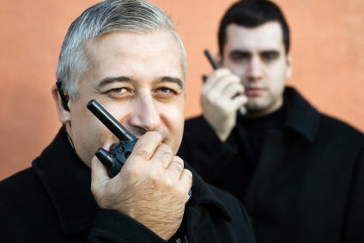
Introduction
You must always try to remain calm when faced with any emergency situation.
This section identifies actions you may be required to take during an emergency ad explains how you can increase the chance of remaining calm when you need to do so.

Dealing with guests/customers in an emergency
When implementing an evacuation/EMP you must stay calm because your actions, attitude and response will greatly influence how others behave.
To deal effectively with guests/customers in an emergency may be required to:
- Apply appropriate interpersonal and communication skills to avoid panic and maintain calm:
- Do not panic yourself – be confident in the training and drills you have participated in: know the plans will work
- Speak clearly and calmly but with authority – speak as if you expect people to comply with what you say
  - Take charge
  - Take control
- Do not yell – unless it is necessary to overcome another noise.
Yelling generates unease and panic
- Exude confidence – in the way you stand, talk and hold yourself
- Provide clear instructions to guests/customers, staff and others:
- Use simple words
- Give brief commands – for example ‘Get out now’, ‘Go there immediately’, ‘Do not run’
- Use appropriate sign language and signals – to accompany the words you use
- Repeat yourself often and as necessary – never expect a single instruction, direction or command to be understood
- Be prepared to ‘show’ and not just ‘tell’ – escort people, accompany them, demonstrate what is required.

Practicing staying calm
The following strategies may assist you staying calm during an emergency situation:
- Take part in all practices and drills undertaken at the venue:
- The more practice you have, the better you will be in an actual situation
- Take the practice seriously – do not treat it is a joke or an inconvenience
- Do not rush – certainly you have to move and act quickly but ‘rushing’ creates panic and simply does not allow you to be or stay calm

- Avoid running if possible
- Do not rush what you say to people
- Wait for responses from people as opposed to assuming they have heard and understood what you have said
- Breathe deeply – this helps oxygen get to your brain
- Work out what to do – you will be calmer if you have a plan of action.
The EMP should be your action plan
- Deliberately put yourself in (safe) situations which raise your level of anxiety – and practice:
- Staying calm
- Coping
- Dealing with those unexpected situations.
- This learning will breed confidence in yourself and your abilities when a real emergency arises
- Undertake a ‘stress management’ course – many of the techniques used to management stress can be used to help you stay calm in an emergency.

4.3 Determine the evacuation route/s to be taken

Introduction
Whenever there is a need to evacuate the property you will need to determine the evacuation route/s to be used.
This section presents factors to consider when identifying the route you will take when faced with a specific emergency.

Primary and secondary evacuation routes
Your EMPs will identify ‘primary’ and ‘secondary’ routes to be used where an evacuation needs to occur.
It is vital you have spent sufficient time studying the EMPs and your workplace to ensure you:
- Know the routes prescribed in the plans
- Have sufficient venue knowledge for the property where you work – so you know things such as:
- Where doors, gates, access and egress points are located
- Which points are locked and unlocked at different times of the day
- Where hallways/corridors lead to
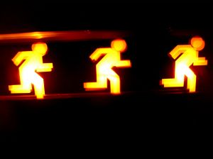
- Where the primary and secondary evacuation points (the designated evacuation assemble areas) are located
- Where evacuation route posters are positioned throughout the building
- Where comms devices and other emergency items (torches/flashlights, first aid kits, emergency keys, are located).
Primary evacuation route
The primary evacuation route is the route which has been determined by management and the safety and welfare (or similar) committee as being the best, safest and most practicable route for moving people from Point A to Point B.
This route will be:
- Included in the relevant EMPs
- Shown on the door of guest rooms
- Highlighted as part of Evacuation posters located throughout the venue
- The focus of evacuation drills undertaken at the venue.
Secondary evacuation route
Wherever possible you should use the primary evacuation route if an evacuation is necessary.
Sometimes, however, especially during an emergency situation it will be impossible to use the primary evacuation route.
Perhaps it is blocked by fire or some structural problem with the building means it is unsafe.
In these cases you will need to turn to a secondary evacuation route.
The secondary evacuation route is your Plan B for evacuating the property.
There may be just one secondary evacuation route or there may be several.
Your training and practice (as well as the personal study you will need to undertake) will make you familiar with these alternate routes.

Primary and secondary evacuation assembly points
Your EMPs will also identify ‘primary’ and ‘secondary’ evacuation assembly points (EAPs).

These are safe locations to which you are expected to move people when evacuating them.
Primary EAPs exist at the end of the primary evacuation route.
Secondary EAPs exist at the end of the secondary evacuation route/s.
The secondary EAP for one evacuation route may be the primary EAP for another/alternate evacuation route.
These locations may have been identified by management, relevant committees and emergency services.
Signage should exist in the venue identifying:
- How to get to the evacuation assembly points/areas
- Location of each evacuation points.

Determining the route to use
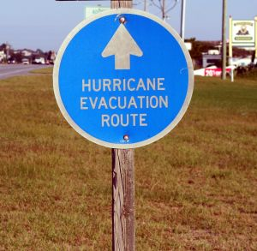
When determining the route to use for evacuation the points listed below must form the basis of your decision making:
- The primary evacuation route should be your first choice unless you believe that route is unsafe or cannot be used
- Secondary evacuation routes must be considered as the next option if the primary route is unavailable to you
- Your personal knowledge of the premises and the layout of passages, doors and other relevant points must be a major factor in deciding the route to use
- Integration of venue knowledge with requirements of the EMP may provide you with a viable option
- Take a moment to consider the nature of the emergency and try to determine where the problem may spread to making sure you avoid the spread of the danger in the route you choose
- Select a passage that will keep your options open to the greatest extent – a route which gives multiple exit points is much more preferable than one with limited (or ‘zero’) options for escape
- Accepting windows can be a viable exit strategy in some situations
- Practice dealing with emergency evacuations where primary and secondary routes are blocked – build experience in working out effective alternate routes
- Understanding during an emergency the back-of-house areas normally ‘off limits’ to guests and customers are freely available for use as an evacuation route.

Blocked or unusable evacuation routes
Exits, evacuation routes and stairways may become blocked or unusable during an evacuation/emergency.
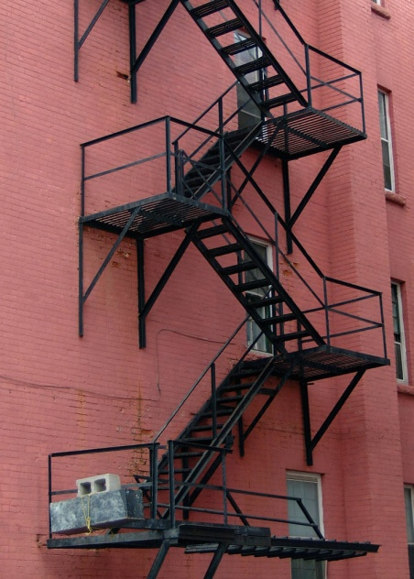
Responses include:
- Remove obstructions where safe to do so – ask others (including guests/customers) for help where necessary
- Use previously designated secondary routes
- Advise chain of command about the blockage – and action (successful or not) to remove the blockage
- Ask chain of command for an alternate route
- Use personal knowledge to determine alternative route.

Unsafe evacuation assembly points
The nature of the emergency or the direction of the wind may render primary evacuation assembly points unsafe.
In these circumstances:
- Use the secondary evacuation assembly points
- Escort evacuees to the secondary points
- Notify chain of command regarding unsafe evacuation point – including:
- Reasons for assembly point being unsafe
- Secondary evacuation point to be used
- Reassure evacuees they are safe.

4.4 Check for persons left in the premises

Introduction
Every evacuation should include a check for persons left in the premises.
This section looks at requirements necessary to ensure no-one remains in the building when an evacuation has been conducted.

Role of preparation
Plans
The plans developed for emergencies and evacuations should:
- Allocate responsibilities for verifying ‘areas clear’ – this means individual staff will be given specific duties to check areas to make sure no-one remains in those areas.
When they have checked and verified these areas they will report this fact back to the CCC who will, in turn, pass this on to emergency services
- Allocate specific locations for named staff to check – so the entire property (or all the area involved in the evacuation) has been checked and verified as ‘all clear’
- Determine the sequence in which the allocated areas should be checked
- Identify reporting requirements – so personnel communicate to the CCC that areas have been checked and are clear.
Training
The training of staff for checking for persons left in the premises as part of an evacuation should address:
- Formal evacuation drills – which have a specific focus.
The focus for each drill should vary so that staff are exposed to a variety of ‘realistic’ situations.
Drills should be proper and detailed dress rehearsals’ rather than ‘activities’ simply designed to ‘tick the box’ for complying with legally imposed requirements to hold drills
- Drills at different times of the day – with an emphasis on drills at night because most fires occur at night in accommodation venues
- Drills on different days of the week – because the pattern and level of trade can vary significantly on different times
- Drills during high season and low season – the requirements for handling an evacuation are remarkably different when the property is at 95% occupancy than when it is at 20% occupancy
- Integration of realistic ‘problems’ into the drills – for example the evacuation drill should/could include some factor introducing an element of unpredictability or surprise into it.
For example the drill may involve:
- Locked doors to which keys cannot be found
- People trapped in rooms
- Blocked primary and/or secondary evacuation routes

Points to note when checking for persons left in the building

When checking for persons left in the premises:
- Make sure you have comms before starting your search.
It is vital you can communicate with others/CCC while you are searching – this is for your own personal safety, to enable you to summon assistance for others and so you can update the status and progress of your search/checking activities
- Obtain necessary PPE and clothing before you start your search – this may include:
- Hard hat/protective helmet
- Coloured vest
- Whistle
- Flashlight
- Follow the EMP requirements which have been set/allocated – this will/could involve front-of-house and back-of-house areas
- Physically search all the areas for which you have been allocated responsibility – let others search the other areas.
You cannot effectively search all the areas on your own.
Advise CCC if you are unable to search any of the areas allocated to you
- Make sure (as appropriate) you:
- Look behind doors
- Open closed doors and look inside rooms and any cabinet large enough to hold a human
- Close any open doors – to help reduce flow of air to the fire
- Call out as you search (for example):
- “Security. Anyone here?”
- “Hotel Rescue. Is anybody in here?”
- Communicate your progress of searched with the CCC – tell them of each ‘clear area’ as you confirm there is no one left there
- Never place anyone else at risk – do not ask them to help if their assistance would put them at risk
- Maintain/preserve your own safety at all times – never put yourself in harm’s way: never try to be a hero

- If you identify people who are trapped in an area you are checking:
- Determine numbers
- Advise CCC of location, numbers and type of entrapped (locked door; fallen structure; flames)
- Ask for assistance
- Do what you can to help release those who are trapped without putting yourself in danger – CCC will allocate any remaining areas to be checked to another person
- If you identify people in an area you are checking:
- Advise CCC you have located people
- Advise CCC people are not trapped
- Advise CCC of action you are taking – for example:
- Leading them to safety/emergency EAP
- Directing them to an exit
- Maintain your Situational Awareness – monitor:
- What is happening
- What is being impacted
- Spread of the problem
- Changing circumstances
- What is causing those changes
- The risk you are at and the threats you are facing
- How you might respond in the threats materialise into a real-life danger situation.
You need to do this so you do not get trapped and so you do not become a victim.

4.5 Account for those who have been evacuated

Introduction
Whenever you have need to evacuate people from the property there is an attendant need to account for those who have been evacuated.
This section describes aspects of this requirement.

Need to account for people

When an evacuation has been conducted you need to:
- Account for those who have been evacuated
- Account for everyone:
- Registered as staying in the venue as a house guest
- Known to be using any facility in the venue
- Known to be ‘on the premises’ at the time.
This needs to be done in order to:
- Determine if people are still in the building – perhaps they are trapped or perhaps they are unaware an evacuation has been initiated.
Emergency services will start undertaking search and rescue activities in areas you have identified people are located
- Confirm people on the premises have been safely evacuated.
- Emergency service workers do not want to risk their lives entering dangerous areas if they know there is no reason to do so – that is, all the people have been evacuated and everyone has been accounted for
- Discharge ‘duty of care’ responsibilities for the safety of guests and customers.
The venue may need to be able to demonstrate/prove to a Court of law they took all reasonable precautions/actions to ensure customers and guests were safe.

Accounting for people
‘Accounting for’ people means ‘knowing where they are’.
They may be:
- Evacuated and safe – meaning they may be in an evacuation assembly area, or they may have been recorded as reaching the evacuation assembly area but have departed from there and may be:
- With family of friends
- In hospital
- At another venue
- In a safe part of your venue awaiting instructions about what to do next
- Trapped – these are people who are known to be (or suspected of being) trapped somewhere in the building
- Unaccounted for – meaning they are ‘absent’ or ‘missing’.
- It is not known if they are:
- Evacuated and safe – they may have evacuated but not reported in, or been recorded by staff as having escaped
- Trapped
- Away from the venue – and not present when the emergency occurred.

Confirming the numbers
Accounting for those involved in an evacuation will require a number of people to undertake a range of tasks.
It is only when all of the following have been completed that you can determine whether or not everyone has been accounted for.

To confirm numbers of people needing to be accounted for you will need to cooperate with management and other staff.
The basic requirements for confirming numbers are:
- Refer to internal documentation – such as:
- Records of people registered as staying in the venue as house guests – all venues are required to maintain such a record
- Bookings sheets for restaurants, dining areas., sports facilities, entertainment areas
- Staff records – which are rosters of staff on duty at the time
- Records of people registered as being present at the designated EAPs (‘Evacuation Register’ or similar)
- Refer to in-house CCTV footage – to identify where possible people who left the building on their own initiative and/or without moving to designated assembly points.
- Guests and customers are not under a legal obligation to assemble at the evacuation assembly points
- Talk to managers, supervisors and staff – to obtain their insight into:
- Who was present at the time the evacuation was initiated
- Knowledge about people who have evacuated and left the scene without being registered/recorded as having evacuated
- Conduct a head count – and compare ‘known numbers’ (those who can definitely/without doubt be accounted for) against the number of people known or suspected of being in the venue at the time.
- Prepare a detailed list as a result of all the above which can be:
- Given to authorities
- Provided to CCC
- Used as a reference point for follow-up activities (see below)
- Liaise with emergency services – to identify any people they may have:
- Rescued – and perhaps hospitalised
- Identified as trapped or deceased.

Caring for the evacuees
Once again you must follow the requirements of your internal plan for evacuation but a standard requirement is to ensure those who have been evacuated are cared for.
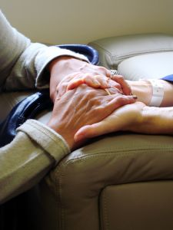
The following provides examples of what may need to be provided:
- A reassuring presence:
- Talking to people
- Checking they are OK
- Asking what they need
- Giving them attention
- Providing medical attention as required – which can include:
- Providing first aid
- Making a first aid kit available
- Obtaining medical care and/or transport to hospital
- Counselling
- Supplying clothing – this is a special need when an evacuation has to be conducted at night and people may not be wearing suitable clothes
- Providing something for people to eat and drink:
- Avoid providing alcohol – even if guests request it and state they are willing to pay
- Have hot and cold drinks
- Provide food such as sandwiches and filled rolls
- Advice regarding toilet and other facilities – especially advice about alternative safety and shelter
- Notifying family and friends on behalf of guests/customers – that they are all right and safe
- Arrangements for re-housing evacuees – there can be times when it is obvious there is a need to contact other venues and make bookings for your guests to stay at alternate accommodation
- Providing information to those who have evacuated about the situation and the progress being made in returning things to normal.
One of the greatest criticisms of venues after an evacuation/emergency is guests and customers believe they are never given enough information, they are not given it in a timely manner and they are often told untruths.

Following up
When people are identified as missing/unaccounted for you should follow any protocols which have been established by your venue for dealing with these circumstances.
Where no direction exists in this regard the points below provide a basis for action:
- Advise the emergency services – by:
- Notifying names
- Giving information about last known location of each person
- Supplying any contact details you have about them
- Advise CCC of the same details – they may:
- Initiate searches by designated venue staff who have been tasked with SAR responsibilities
- Coordinate with authorities regarding action to take/searches
- Use known contact details and other information known about guests/customers and staff to attempt to contact them – common actions are:
- Phoning their cell phone
- Calling their known friends, family and/or associates
- Calling locations (businesses, tourist attractions, recreation centres) they are thought to be attending or where it is deemed possible they might be
- Use the media – asking them to broadcast/publish a request for people who were staying at or using the venue on the day and at the time in question to ring a designated/CCC room number to advise they are safe.

Work Projects
It is a requirement of this Unit you complete Work Projects as advised by your Trainer. You must submit documentation, suitable evidence or other relevant proof of completion of the project to your Trainer by the agreed date.
4.1 Develop and submit a sample Evacuation Plan which may be used to evacuate guests from one (only) above ground floor in a designated accommodation venue.
The plan must:
- Identify the venue and the floor
- Describe procedures to evacuate guests from their rooms to a designated EAP using a primary evacuation route
- Explain the procedures to be followed to check for persons left in rooms on the nominated floor
- Describe procedures to follow to account for those who have been evacuated.
4.2. Develop and submit a list of suggestions or instructions which could be given to new staff at an accommodation venue to help them maintain calm while dealing with an emergency and evacuating guests/customers.

Summary

Conduct evacuations
When conducting evacuations:
Follow internal procedures and plans
Activate the relevant alarm
Notify emergency services
Notify designated internal personnel
Notify and assist patrons and guests
Use common sense and venue knowledge to respond to unforeseen circumstances
Maintain communication with others
Never put yourself or others in danger
Maintain calm
Use primary evacuation routes if possible
Be prepared to use or create secondary routes as the need arises
Maintain Situational Awareness
Evacuate people to designated EAPs
Check for people left in the building according to allocated personal responsibility
Care for those who have been evacuated
Assist in accounting for those who have been evacuated.

Element 5:
Fulfil administrative responsibilities

5.1 Complete necessary internal forms and reports


Introduction
A primary task of fulfilling administrative duties when maintaining the safety of premises and personnel is the need to complete necessary forms and reports.
This section identifies examples of documentation which may need to be completed and describes the matters which need to be recorded.

Background information
In relation to the need to complete internal forms and reports:
- These vary between venues – what is required in one venue is not required in another; what does not have to be reported/recorded in one premises does have to be reported/recorded elsewhere
- It is important to complete the documents in a timely manner – in practice this means filling in reports and records ‘immediately’ after an incident, event or nominated activity
- Completed documentation needs to be ‘forwarded’ – there is always a need to file a form or hand it in to a designated person/department
- Accuracy is vital – it is essential you take the time to make sure all the details (information as well as statistical data) is correct in every aspect
- Obtain necessary in-house training – all venues will provide advice and instruction on:
- Which documents to use when a report/record is required
- How to complete the required
- When to complete them
- What to do with them when they are completed
- Make an effort to look at records/reports others have completed – to get a ‘feel’ for how they complete them, the language and phrases used, and the detail included
- Keep a copy of any records/reports you complete – for your own records/purposes ‘after the event’
- Seek advice – when uncertain about:
- Whether a record/report is required
- Details/information required.

Documentation format
Required forms and reports will usually be in one of two basic format options:
- Paper-based – meaning there is an actual piece of paper which has to be completed
- Electronic – meaning you will have to access a computer and complete the details (‘required fields’).


Examples of forms and reports
Types of forms and reports will vary between venues.
Some of the items identified below may be combined by some operators into the one document which then becomes a multi-purpose form.
Forms and reports you may be required to complete can include:
- Communications book – used by venues to facilitate communication between staff who work different shifts/days
- Vehicle use form – detailing name of person who used the vehicle, reason for use and odometer readings
- Incident report – to record details relating to an incident which has occurred in the venue
- Compliance reports – detailing action taken to comply with requests/demands from management and/or authorities
- Loss and damage assessments – to record details of events which have caused loss or damage to the venue, stock, facilities or guest items
- Maintenance Request forms – also known in some venues as Maintenance Requisitions
- Maintenance reports – detailing repairs, service and maintenance on items specifying what was done, when it was done and who did it. This form is required when maintenance is undertaken by internal staff or an external provider.
- Time sheets – detailing hours worked for a shift: a time clock may replace the need to complete a paper-based time sheet
- Task assignments – at the end of the allocated assignment
- Job cards/sheets – when allocated work (inspections, repairs, replacements) have been finalised this record will detail:
- Who did the job
- Time taken
- Materials used
- Parts and components replaced
- These details enable costing of work done
- Patrol logs – at the end of vehicle and foot patrols completed at the end of the patrol or end-of-shift to record times and routes as well as operational details
- Suspicious person report – completed at the end of the patrol, end-of-shift or after having responded to a call from venue staff to investigate
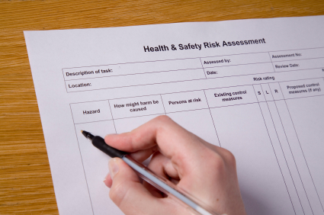
- Insurance claims – lodging a claim on behalf of the venue against an insurance policy held by the property
- CCTV surveillance records – to identify discs/tapes stored/maintained for different dates, times and locations/cameras
- Alarm reports/activity logs – identifying activated alarms, locations, times and causes including false alarms
- Response reports – detailing action taken in response to alarms and calls for assistance
- Equipment faults log – this is used to report operational faults in systems and equipment and to record action taken to record diagnoses
- Testing and inspection records – which:
- Provide evidence of inspections/tests having been undertaken
- Highlight areas where problems/issues have been identified for further action/follow-up
- Witness statements – taken when members of the public are prepare to make statements regarding what they observed when an event, incident or offence took place.
Members of the public, customers or guest are under no obligation to make witness statements
- Lost and Found register – detailing items which have been found in the venue and items which have been reported as lost as well as items returned to their owners
- Recommendations for action – this is a form allowing staff to formally convey suggestions and ideas for issues such as:
- Changes to SOPs
- Introduction of new SOPs
- Replacement of items
- Disposal of faulty or damaged equipment
- Purchase of new/different items and equipment
- Request for training – identifying the training required (such as ‘initial training’, ‘top-up training’ or ‘refresher training’) and the items (equipment and/or systems) involved.
This training request may also identify ancillary areas in which training is required – these areas may include:
- First aid
- Maintenance and service.

5.2 Cooperate with management in making recommendations to enhance patron and staff safety

Introduction
An ongoing aspect of safety work is to cooperate with management to optimise safety at the venue.
This section identifies a range of options for supporting management actions to improve safety at a venue and advice in relation to providing recommendations for action.

Ways to support management to optimise venue safety
You should participate in a range of activities to demonstrate your support for management in their endeavours to optimise safety at the venue:
- Engage actively with all aspects of risk management when the need to do so arises – risk identification, risk analysis and risk control
- Participate in regular staff briefings, de-briefings and meetings
- Participate in scheduled workplace inspections – to:
- Confirm existing safety arrangements
- Identify new threats/problems
- Attend conventions, seminars and conferences which have a safety focus – and report back to management on what you discovered/became aware of
- Contribute ideas, suggestions and recommendations for improvement to enhance patron and staff safety – see ‘Making recommendations’ below
- Be willing to trial safety initiatives – and provide feedback on their implementation and effectiveness
- Compete all internal forms and reports as required – management use these to determine the need for changes to existing safety-related arrangements
- Visit other venues – to determine the safety protocols they have in place
- Develop an industry network of personnel who have an interest in, and involvement with, venue safety – and communicate regularly with them to share information
- Take the time and make the effort to analyse and evaluate indicators of safety-related performance by the venue (such as internal reports, comments by and feedback from staff and guests) – and provide details of your finding to management
- Fully complying with management directives – regarding need for compliance with:
- Existing safety policies and procedures
- Revisions to safety policies and procedures
- Introduction of new safety policies and procedures.

Making recommendations
When making recommendations for action:
- Make verbal suggestions first
- Supplement these with written recommendations:
- If the verbal notification is of interest
- If requested

Content of written recommendations
When you prepare a written recommendation regarding safety you should address the following points in your submission:
- Your name and contact details
- Date – the recommendation was written/submitted
- Rationale for the recommendation – explaining why the recommendation is being made
- Action plan for implementation – setting out sequential and step-by-step activities necessary to trial/pilot and implement the recommendation
- Recommendation regarding:
- Equipment, systems and technology to be used – including any supporting product information (brochures, quotations, fact sheets)
- Provider, supplier and/or installer who should be employed
- Timelines for implementation
- Training required to support the initiative
- Details of any new staff required – or additional staff hours required
- Transitional arrangements (where applicable) – detailing how the initiative/recommendation will be phased in to/integrated with other SOPs of the workplace
- Explanation of the benefits which should flow – from implementation of the initiative/proposal
- Cost involved – including, as appropriate:
- A cost-benefit analysis
- Money which may be received as a result of sale of ‘old’ equipment

Work Projects
It is a requirement of this Unit you complete Work Projects as advised by your Trainer. You must submit documentation, suitable evidence or other relevant proof of completion of the project to your Trainer by the agreed date.
5.1 Interview a relevant industry person and ask them to identify the internal forms and reports they need to complete in order to fulfil their administrative responsibilities for maintaining the safety of premises and personnel.
Prepare a submission based on their answers and:
- Include a copy of documents (if available)
- Explain the role for each identified document
- Describe when each document has to be completed.
5.2. You have identified a suggestion which you believe will enhance patron and/or staff safety.
Prepare a submission which:
- Briefly describes the suggestion
- Explain how/why the suggestion will enhance patron and/or staff safety
- Describes how you will present your suggestion to management.

Summary

Fulfil administrative responsibilities
When fulfilling administrative responsibilities:
Complete all required internal forms and reports
Complete documents in a timely manner
Focus on accuracy, honesty and comprehensiveness when completing forms
File and forward forms and reports
Cooperate with management to optimise staff and patron safety
Attend all safety-related staff meetings
Participate actively in venue-specific safety inspections, checks and initiatives
Offer verbal recommendation
Be prepared to supplement verbal recommendations with written recommendations.

Element 6:
Respond to a deceased person situation

6.1 Contain the situation relating to the body

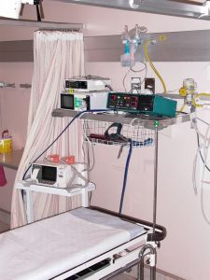
Introduction
A deceased person situation is distressing for everyone involved but must be handled professionally.
This section identifies critical requirements relating to containing the situation as a basic first step in dealing with these situations.

The context
The following helps provide a context for deceased person situations:
- The incidence of deceased persons in the industry is very, very low
- A ‘deceased person situation’ means a situation where a person is found to be dead on the premises
- The deceased person may be a guest who is staying in a room at the venue or a member of the public who was drinking or dining at the venue, or who had wandered into the premises
- Death may have been occasioned by:
- ‘Natural causes’ – such as:
- People passing away in their sleep
- Old age
- Results of a medical condition
- An accident – such as:
- Choking
- A fall
- Criminal action – such as:
- An assault
- Homicide
- Suicide
- Many venues have developed their own protocols for handling deceased person situation and where these exist it is important they are adhered to.

Primary aims when a deceased person is identified
If you discover a deceased person the following provide an acceptable course of action:
- Immediately notify Front Office, Security or the designated department or person in the venue – this must be the non-negotiable first step before you do anything else.
You must notify someone internally you have discovered what you believe to be a dead body.
This is done so assistance will start moving your way immediately.
The venue may have a special code for this situation – for example:
- “This is David in Room 236. We have a code 83 here”
- “This is David at the swimming pool. Code 83. Single male.”
- Do not touch anything at the scene – you must ‘preserve the scene’.
See section 6.4 for more detail
- Do what you can to provide assistance and comfort to those who may be impacted – see section 6.5
- Never talk to guests, members of the public or the media about the deceased person or the situation – leave this to management, the authorities or the designated venue PR person
- Take whatever action is necessary given the circumstances to maintain dignity for the deceased – this can include:
- Talking in a quiet voice
- Using respectful language.

Containing the situation
‘Containing the situation’ means taking action to limit the impact of the deceased person on others.
The following actions will help achieve this:
- Doing whatever is required to prevent others seeing the body – this may require you to:
- Close doors
- Lock doors
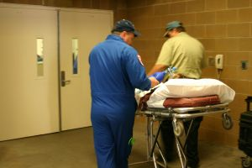
- Draw curtains or blinds
- Block pedestrian and/or vehicular traffic – but ensure you create alternative traffic routes to help maintain movement past the situation
- Arrange for Security guards to be posted to restrict access
- Erect a physical barricade around the body

- Refraining from talking about the situation so guests and members of the public can hear what is being said – this includes:
- One-to-one conversations with venue staff
- Telephone discussions
- Conversations at the time the body is discovered as well as at later times
- Limiting the fallout from the event – this means dong what you can to maintain normal venue operation to the best extent possible:
- Making sure your responses are reasonable and not over-reactive – be certain to use common sense at all times
- Avoiding shouting.

6.2 Contact emergency services

Introduction
It is important to contact emergency services as part of your response to a deceased person situation.
This section describes what is required in this regard.

Who to contact
The standard response to what is assumed to be a deceased person situation is to activate a ‘dual response’.
This means the venue must contact:
- Police:
- So they can investigate the situation
- Ambulance:
- So they can:
- Verify the person has indeed passed away
- Render necessary first aid in the event the person has not died.

Contacting emergency services
Contacting the emergency services should occur in accordance with the following:
- Allow Front Office, Security or the nominated person you have already contacted (see section 6.1 ‘Primary aims when a deceased person is identified’) to contact the emergency services
- If you have to make the call:
- Make it as soon as possible
- Use landline or cell phone
- Make sure no guest or member of the public can hear you make the call

- Log the call – so the venue can demonstrate:
- It made the call
- The time the call was made’
- Name of the person who made the call

Information to provide
When speaking to the operator to report the deceased person situation you can expect o be asked for different information than when, for example, reporting a fire.
The procedure is to ring the emergency number and:
- Advise them you are reporting a dead body situation – and allow them to take the lead in terms of asking questions they want you to answer
- The operator will ask questions such as:
- Name of venue
- Address
- Nearest cross street/intersection
- Your name
- Number of bodies
- Number of injured people
- Possible cause of death
- Is there a weapon present/visible?
- Are other people in danger/at threat?
- Location of the body within the venue – room number, name of the room the body is in or external location
- Directions on how to get to the body
- You may contribute the following to the exchange with the operator:
- Request for dual response
- Suggestion for location for attendance of emergency vehicle/s
- Advice someone from the venue will be there to direct officers to ‘the scene’

6.3 Contact management

Introduction
It is standard procedure for management to be contacted whenever there is a deceased person on the premises.
This section explains this requirement.

Contacting management
Timing
You must contact management in accordance with your internal protocols.
Some venues will require emergency services to be contacted before management, and other venues will require you to advise management before contacting management.
Find out what applies in your workplace and adhere to that.
If there is no SOP, you are advised to contact emergency services first.
Note: once you have contacted Front Office, Security or the nominated person (see section 6.1 ‘Primary aims when a deceased person is identified’) the usual procedure is for them to contact management.
Information to provide and questions to ask
If circumstances are such you have to contact management when a deceased person has been discovered on the premises you should do so:
- Promptly – with reference to ‘Timing’ above.
The owner or Duty Manager must be notified as soon as possible.
- Using the telephone – making sure the conversation cannot be heard by customers/guests or members of the public
- Telling them your name and where you are speaking from
- Providing information:
- About the body – covering aspects such as:
- Where it is
- Who it is
- Your first thoughts about cause of death with a focus on whether you believe the death was as a result of natural causes or whether ‘foul play’ is obvious or suspected
- About the scene – in relation to:
- Whether or not others are aware of the body
- If the body is visible to the public
- Has a crowd gathered at the scene
- What action you have taken – to this point, for example:
- Whether you have notified emergency services or not
- Whether you have notified Front Office or not
- Suggestions for action – in order to:
- Minimising alarm and concern among guests
- Preventing access to the scene by members of the public
- Secure/preserve the scene
- Asking questions – about:
- What they want you to do
- What they do not want you to do
- Who you should contact

6.4 Preserve the scene where the body was found

Introduction
Whether the deceased person is found inside the venue or in an outside area of the property it is important you ‘preserve the scene’.
This section identifies what is required to preserve the scene.

Importance of preserving the scene
All deaths in any location of a venue must be investigated by the authorities.
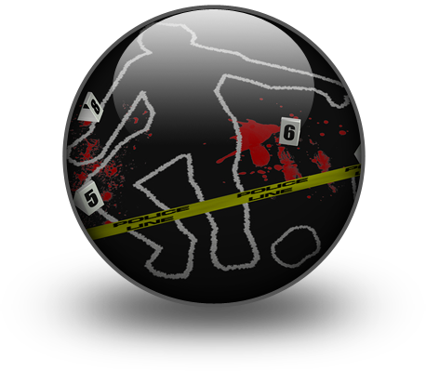
Whether a guest dies in their bed during their sleep, a person dies after collapsing in the restaurant or someone is murdered in the lobby the death must be investigated to determine the cause and, where applicable, identify the perpetrator of any crime which may have been committed.
To help investigators undertake their work it is essential the ‘scene’ where the body is found is maintained in the condition it was in when the body was found.
This is important to:
- Avoid contamination of the scene – by allowing material to be ‘walked into’ the scene or otherwise introduced into the scene
- Avoid contamination of evidence which may be present at the scene – such as weapons
- Allow investigators to view (and photograph) the scene exactly as it was when the ‘event’ (the death of the person) occurred
- Enable the officials to take notes about the scene for their later investigation.

Preserving the scene
The following actions will help preserve the scene where a deceased person in discovered:
- Not touching the body
- Not moving anything in the room where the body was found – such as re-locating items

- Not touching or moving anything in the immediate vicinity of where the body was discovered
- Not allowing others into the area/room
- Preventing others walking through the area
- Not permitting anyone taking/removing anything from the scene
- Making sure no-one else moves items at the scene.

Taking additional action
Depending on the circumstances you may also:
- Recall your own actions which have already been taken which may have inadvertently contaminated/altered the scene – for example, you might note:
- How you entered the room/area
- Things you actually did touch/move – before you knew you were involved in a deceased person situation
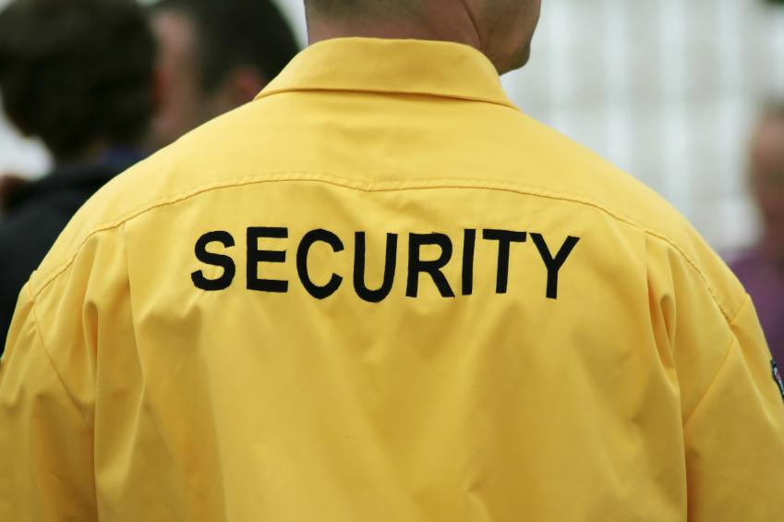
- Take note of the other people who were present when the body was discovered – so their names/description can be passed on to police
- Ask any witnesses to remain so they can assist the authorities with their enquiries – note you do not have the power to:
- Insist or detain people remain until the police arrive
- Demand people give a witness statement.

6.5 Comfort those affected by the death

Introduction
It is standard practice for a venue to provide comfort to those who may be impacted by a death on the premises.
This section identifies what may be done in this regard.

Who may be affected
You need to be aware the people impacted by a deceased person on the premises may include:
- Family and friends of the deceased
- Other guests and customers in the venue
- Staff.
Members of the public who are nor guests or customers are not usually provided with attention or comfort.

Providing comfort
The guidelines for providing comfort are:
- Follow internal procedures which apply – which will identify:
- Staff to be involved
- Locations where people should be taken (away from the scene)
- Actions which can be taken to provide comfort
- Always use common sense – about:
- What to do
- What to use
- Priorities
- Comfort guests and customers before comforting staff
- Comfort children before adults – unless their parents are present, in which case allow the parents to comfort their children
- Remove children from the area – they may be transfixed and remain staring at what they see so they often need to be led away
- Accept and understand the person is genuinely going through a very difficult situation – this is especially the case where the deceased is a friend or family member regardless of how the death took place

- Use the following to provide comfort – this is required to those who may be related to the deceased person or people who are distressed at having seen the body and/or the circumstances surrounding the body:
- Remove them from the scene
- Words of comfort/consolation
- Reassurance
- A hot beverage – never offer alcohol
- Tissues
- A ‘shoulder to cry on’
- A physical presence – someone to talk to.
It is critical to understand many people impacted in this way simply want someone to talk to. They do not really need you to say anything/much but they need to know you are listening, and you are ‘there’ sharing their experience

- Offer to contact family or friends
- Avoid:
- Telling them to ‘be strong’
- Telling them you know what they are going through
- Ask them to tell you what they want/need to cope with the situation – “What can I do for you?”
- Obtain external professional help (counselling) to cope with the situation
- Be alert to the potential for people to be affected by shock – and provide first aid for same
- Provide formal de-briefing sessions with staff – to help them come to terms with what has happened and assist in the general recovery process.

Work Projects
It is a requirement of this Unit you complete Work Projects as advised by your Trainer. You must submit documentation, suitable evidence or other relevant proof of completion of the project to your Trainer by the agreed date.
6.1 Prepare a Checklist or set of directions which could be used by staff at a venue to respond to a deceased person situation.
The submission must provide information on the following topics:
- Taking action to contain the situation
- Contacting emergency services to advise them of the situation
- Contacting management
- Reserving the scene where the body was found
- Contacting those affected by the death.

Summary

Respond to a deceased person situation
When responding to a deceased person situation:
Follow house protocols where they exist
Treat the deceased person with respect
Contain the situation to the best of your ability at the time
Notify management or the designated person immediately
Contact emergency services and ask for ‘dual response’
Prevent access to the scene by others
Do not touch anything
Do not touch the body
Do not contaminate the scene
Comfort guests and staff impacted by the death.

Presentation of written work

1. Introduction
It is important for students to present carefully prepared written work. Written presentation in industry must be professional in appearance and accurate in content. If students develop good writing skills whilst studying, they are able to easily transfer those skills to the workplace.

2. Style

Students should write in a style that is simple and concise. Short sentences and paragraphs are easier to read and understand. It helps to write a plan and at least one draft of the written work so that the final product will be well organised. The points presented will then follow a logical sequence and be relevant. Students should frequently refer to the question asked, to keep ‘on track’. Teachers recognise and are critical of work that does not answer the question, or is ‘padded’ with irrelevant material. In summary, remember to:
- Plan ahead
- Be clear and concise
- Answer the question
- Proofread the final draft.

3. Presenting Written Work
Types of written work
Students may be asked to write:
- Short and long reports
- Essays
- Records of interviews
- Questionnaires
- Business letters
- Resumes.
Format
All written work should be presented on A4 paper, single-sided with a left-hand margin. If work is word-processed, one-and-a-half or double spacing should be used. Handwritten work must be legible and should also be well spaced to allow for ease of reading. New paragraphs should not be indented but should be separated by a space. Pages must be numbered. If headings are also to be numbered, students should use a logical and sequential system of numbering.
Cover Sheet
All written work should be submitted with a cover sheet stapled to the front that contains:
- The student’s name and student number
- The name of the class/unit
- The due date of the work
- The title of the work
- The teacher’s name
- A signed declaration that the work does not involve plagiarism.
Keeping a Copy
Students must keep a copy of the written work in case it is lost. This rarely happens but it can be disastrous if a copy has not been kept.
Inclusive language
This means language that includes every section of the population. For instance, if a student were to write ‘A nurse is responsible for the patients in her care at all times’ it would be implying that all nurses are female and would be excluding male nurses.
Examples of appropriate language are shown on the right:
Mankind | Humankind
Barman/maid | Bar attendant
Host/hostess | Host
Waiter/waitress | Waiter or waiting staff

Recommended reading
Note: all Recommended Reading is sourced from ‘Trove: National Library of Australia’ at http://trove.nla.gov.au/
Ashton, Yvonne 2007, Hospitality: health, safety & security, Blake Education, Sydney, NSW
Barth, Stephen C 2012, Hospitality law: managing legal issues in the hospitality industry, 4th ed, Wiley, Hoboken, N.J
Brooksbank, David 2007, Security manual, 8th ed, Gower, Aldershot
Clifton, Darrell 2012, Hospitality security: managing security in today's hotel, lodging, entertainment, and tourism environment, CRC Press, Boca Raton, FL
Fay, John, 1934- 2007, Encyclopedia of security management, 2nd ed, Butterworth-Heinemann, Burlington, MA
Fischer, Robert J & Halibozek, Edward P & Green, Gion 2008, Introduction to security, 8th ed, Butterworth-Heinemann, Burlington, MA; Oxford, UK
Mansfeld, Y. (Yoel) & Pizam, Abraham 2006, Tourism, security and safety: from theory to practice, 1st ed, Elsevier Butterworth-Heinemann, Burlington, Mass
Walker, John R 2013, Introduction to hospitality management, 4th ed, Pearson, Boston

Trainee evaluation sheet

Maintain the safety of premises and personnel
The following statements are about the competency you have just completed.
Please tick the appropriate box | Agree | Don’t Know | Do Not Agree | Does Not Apply
There was too much in this competency to cover without rushing.
Most of the competency seemed relevant to me.
The competency was at the right level for me.
I got enough help from my trainer.
The amount of activities was sufficient.
The competency allowed me to use my own initiative.
My training was well-organised.
My trainer had time to answer my questions.
I understood how I was going to be assessed.
I was given enough time to practice.
My trainer feedback was useful.
Enough equipment was available and it worked well.
The activities were too hard for me.

The best things about this unit were:

The worst things about this unit were:

The things you should change in this unit are:

Trainee self-assessment checklist
As an indicator to your Trainer/Assessor of your readiness for assessment in this unit please complete the following and hand to your Trainer/Assessor.

Maintain the safety of premises and personnel
 |  | Yes | No*
Element 1: Respond to fire and other alarms
1.1 | Establish nature and location of alarm
1.2 | Contact emergency service providers
1.3 | Ensure access and assistance to emergency services upon their arrival
1.4 | Provide first response assistance
Element 2: Respond to safety threats
2.1 | Manage patrons who are displaying inappropriate behaviour
2.2 | Make safe areas that are identified as being unsafe
2.3 | Respond to suspicious packages
2.4 | Respond to bomb threats
Element 3: Respond to emergency situations
3.1 | Identify the nature and scope of the emergency
3.2 | Contact emergency services
3.3 | Implement the Emergency Management Plan for the premises
3.4 | Provide first response assistance
3.5 | Maximise safety of personnel during the emergency
Element 4: Conduct evacuations
4.1 | Adhere to the requirements of the internal Emergency Management Plan for the premises
4.2 | Maintain calm
4.3 | Determine the evacuation route/s to be taken
4.4 | Check for persons left in the premises
4.5 | Account for those who have been evacuated
Element 5: Fulfil administrative responsibilities
5.1 | Complete necessary internal forms and reports
5.2 | Cooperate with management in making recommendations to enhance patron and staff safety
Element 6: Respond to a deceased person situation
6.1 | Contain the situation relating to the body
6.2 | Contact emergency services
6.3 | Contact management
6.4 | Preserve the scene where the body was found
6.5 | Comfort those affected by the death

Statement by Trainee:
I believe I am ready to be assessed on the following as indicated above:
Signed: _____________________________ | Date: ____________

Note:
For all boxes where a No* is ticked, please provide details of the extra steps or work you need to do to become ready for assessment.





